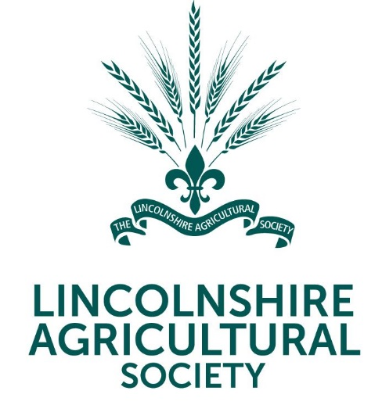 | 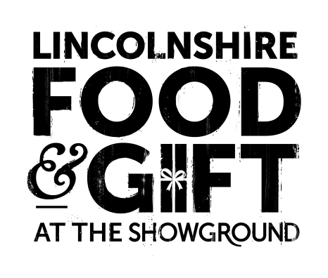

News Release

20th September 2023

Tickets Go On Sale for Lincolnshire Food & Gift Fair

Christmas has come early for shoppers in Lincolnshire! Tickets have just gone on sale for the annual Food & Gift Fair at the Lincolnshire Showground on Saturday 25 and Sunday 26 November.

The two-day indoor event, from 9am till 4pm, is a firm favourite with families looking to make their festive celebrations truly special.

As well as unique gifts, handmade crafts and delicious treats, children can explore Santa’s Workshop and have a go at arts, crafts and baking activities.

Lincolnshire Agricultural Society Chief Executive Charlotte Powell said: “We’re really excited about this year’s event. With over 150 exhibitors, including food and drink retailers, growers and producers, it will be a perfect opportunity to buy a one-of-a-kind gift for your loved ones.

“And with free entertainment for the whole family to enjoy, including Christmas decoration making and carol singing by local choirs, it promises to be a popular event so make sure you get your tickets early!”

Over the two days, visitors to the Food & Gift Fair will also be able pick up some expert tips in the Lincolnshire Kitchen to help them prepare a culinary holiday feast.

Great British Bake Off contestant Sandy Docherty along with local chefs Dominic Franks of ‘Dom in the Kitchen’ fame and Steph Dexter, Head Chef at Cross Keys Inn at Grasby, will be giving cookery demos and of course, there will be plenty of samples to try!

Tickets cost £5.50 (plus a booking fee) in advance from lincolnshireshowground.co.uk/food-gift or £7.00 on the door. Children under five and parking are free.

For more information, please visit lincolnshireshowground.co.uk/food-gift

Ends

Note to Editors

- The 270-acre Lincolnshire Showground is owned by the Lincolnshire Agricultural Society (LAS) which was formed in 1869 and celebrated its 150 anniversary in 2019.
- As a charitable organisation its objectives are to educate the county about food, farming and a sustainable environment. 100% of surplus funds from events are gift aided back into the charity to deliver the charity’s educational work.
- For more information, please visit lincolnshireshowground.co.uk

For media enquiries please contact:
Kate Strawson
Director
Shooting Star
kate@weareshootingstar.co.uk
01522 528 540 / 07733 230 293

