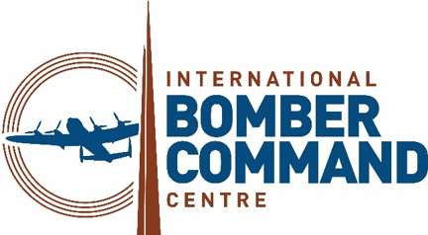

News Release
30th June 2026

Bomber Command Concert to Remember Fallen Men and Women

The sacrifices of the men and women who served with Bomber Command during WWII will be remembered at a church concert in Louth on Saturday 4th July.

IBCC Voices – Past, Present and Future, at St James’ Church from 7.30pm till 9.30pm, will tell the story of the International Bomber Command Centre (IBCC) and its aims of promoting reconciliation, remembrance and recognition.

Hosted by former BBC Radio Lincolnshire presenter Melvyn Prior, the evening will honour Bomber Command service personnel while also helping to raise money for the IBCC’s educational work with schools and youth groups.

Both uplifting and poignant, the concert will feature songs, readings, poems and music performed by volunteer members of the IBCC Community Choir and Orchestra led by musical directors, Clare Bauckham and Greta Marshall.

The repertoire will include the first ever performance of Remember written by John Roy Walsh, set to music by Clare Bauckham, and an orchestral piece written by musician Rachel Williams.

Guests will also be able to enjoy singing along to wartime favourites such as Nightingale and Dambusters.

To buy tickets or find out about more upcoming IBCC events, please visit internationalbcc.co.uk/visit/events
ENDS

Notes to Editors

The International Bomber Command Centre, which opened on 30th January 2018, provides a world-class facility to serve as a point for recognition, remembrance and reconciliation for Bomber Command.

Since its opening the centre has welcomed over 750,000 visitors from 61 different countries, including over 50,000 schoolchildren through its learning programmes.

The centre has received 40 different awards for interpretation, innovation, ethical, sustainable and responsible tourism, international tourism, heritage and education, including the VisitEngland bronze award holder for Best Large Visitor Attraction and the holder of the King’s Award for Voluntary Services.

The IBCC has involved over 500 volunteers from nine countries who have supported every aspect of the extensive project.

Facebook and LinkedIn: InternationalBomberCommandCentre
X, TikTok and Instagram: @IntBCC

For media enquiries please contact:
Kate Strawson
Director
Shooting Star
01522 528540 / 07733 230293
kate@weareshootingstar.co.uk
www.weareshootingstar.co.uk

