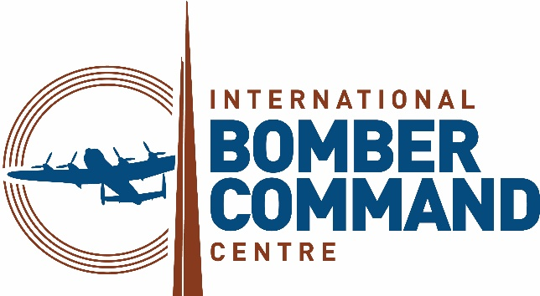 | 

News Release
25th April 2025

Thousands of Poppies Take Flight in Striking VE Day 80 Tribute

A display of over 20,000 ceramic poppies, arranged in the silhouette of a Lancaster Bomber, has been unveiled at the International Bomber Command Centre (IBCC) in Lincoln ahead of the 80th anniversary of Victory in Europe (VE) Day on 8th May.

The striking installation, created by Lithuanian artist Darius Sirmulevicius who now lives in Lincolnshire, will serve as a summer-long tribute to the millions of people across the UK and Commonwealth who served in the Second World War.

The poppies, each one unique, will be available for sale with proceeds going towards the IBCC, Wooden Spoon Rugby Charity and British West India Regiments Heritage Trust.

IBCC CEO Nicky van der Drift said: “During WWII, more than a million men and women served in or supported Bomber Command, and Lincolnshire housed over a third of all the RAF Bomber Command stations.

“In the UK, the red poppy is the national symbol of remembrance. Despite the devastation and horrific loss of life in war-torn Europe, poppies flourished and grew on battlefields and this spectacular display in the shape of a Lancaster Bomber is a fitting tribute to their sacrifice.

“It serves as a point of remembrance, a reminder of the cost of war and an education piece for all ages, which is at the heart of everything we do here.”

The unveiling also marks the launch of VE80 Lincoln – the final stage of the Rugby & World War Two Project, hosted by World Rugby Memorial, designed to honour the 80th anniversary of D-Day (6th June, 2024).

The project, which began in Normandy and continued through Nijmegen and Arnhem, will culminate in Lincoln on VE Day with a series of events at locations across Lincolnshire from 8th to 11th May 2025.

Over 280 young male and female rugby players from U18 teams in the UK, France, the Netherlands and Jamacia will take part in the events including an international VE80 Rugby Festival hosted by Lincoln Rugby Club on Saturday 10th May.

Other VE80 Lincoln commemorative events will include:

- VE Day 80 Beacon Lighting and Dinner – A poignant ceremony on 8th May at the IBCC, marking this significant moment in history.
- Heritage site visits – The Lincolnshire Aviation Heritage Centre and IBCC will host visiting touring U15 rugby teams and VIP guests for immersive experiences.
- Ceramic Poppy-Bluet Ceremony – On 9th May (16:30 till 18:30) a moving tribute will take place at Lincoln Cathedral, incorporating its military altars in honour of those who served.
- Rugby & WWII Exhibition – From now until August the IBCC will showcase a unique exhibition highlighting the connections between rugby and the Second World War featuring untold stories of service, camaraderie and sacrifice.
- Sunday Thanksgiving Service – On 11th May (10:15 till 11:15) the IBCC will host a special service to conclude the commemorations with a message of gratitude and reflection.

The Rugby & World War Two Project, hosted by World Rugby Memorial, is a collaboration of Francourt Events, the International Bomber Command Centre (IBCC), Lincoln Rugby FC, and Sage Blue.

Director of Sage Blue and Co-Chair of VE80 Lincoln Sue Liburd MBE DL said: “The 80th anniversary of VE Day provides a unique opportunity to honour the sacrifices made by millions and educate future generations about the enduring importance of peace and freedom, and what better way to do this than through sport?

“The VE80 Lincoln project, which involves young people from across the Europe and the Commonwealth, combines education, history and rugby, ensuring that the stories of resilience, courage and unity remain relevant and inspiring for years to come.

“The commemorations are more than just a reflection on history, they are an investment in future generations.”

Journalists, photographers and film crews are welcome to attend any of the above events. For more information or to confirm your attendance please call Kate Strawson at Shooting Star on 07733 230293 or email kate@weareshootingstar.co.uk

ENDS
Notes to Editors

The International Bomber Command Centre, which opened on 30th January 2018, has been created to provide a world-class facility to serve as a point for recognition, remembrance and reconciliation for Bomber Command.

Since its opening the Centre has welcomed over 590,000 visitors from 56 different countries, including over 35,000 schoolchildren through our learning programmes.

The Centre has received 40 different awards for interpretation, innovation, ethical, sustainable and responsible tourism, international tourism, heritage and education, including the VisitEngland bronze award holder for Best large Visitor Attraction and the holder of the King’s Award for Voluntary Services.

The IBCC has involved over 500 volunteers from nine countries who have supported every aspect of the extensive project.

Facebook and LinkedIn: InternationalBomberCommandCentre
Twitter and Instagram: @IntBCC

For further media information please contact:

Kate Strawson
Director
Shooting Star
kate@weareshootingstar.co.uk
07733 230293

