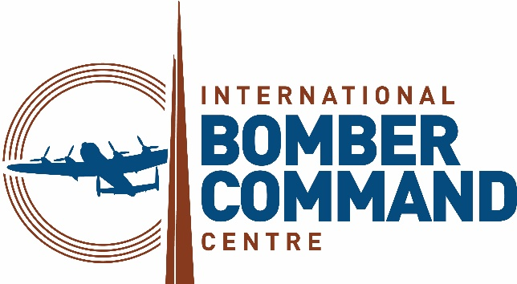 | 

News Release
14th May 2025

WWII Veterans Remember Fallen Commonwealth Comrades

Commonwealth veterans from World War Two and Windrush laid a wreath and visited the spectacular Lancaster Bomber poppy display at the International Bomber Command Centre (IBCC) to remember their colleagues who perished during the conflict.

The visit by Jamaican veterans Ralph Ottey (101), Gilbert Clarke (98) and Sidney McFarlane (90) on Saturday (10th May) was one of a series of events organised as part of the VE80 Lincoln project to commemorate the 80th anniversary of VE Day.

Ralph, an RAF volunteer, served as a driver with 617 Squadron at RAF Coningsby and RAF Woodhall Spa while Gilbert, also an RAF volunteer, serviced the radio and radar systems of British and American aircraft. Both have featured prominently in national VE Day commemorations, and Gilbert was seated next to Anne, Princess Royal during the celebrations in London on Saturday 3rd May.

Sidney was part of the Windrush generation who were invited to the UK to help rebuild post-war Britain. He joined the Royal Air Force in 1958, progressing from aircraftman to squadron leader. During his distinguished career, he was awarded three Commanders-in-Chief commendations for outstanding service.

VE80 Lincoln, which was a collaboration between Francourt Events, the IBCC, Lincoln Rugby FC and Sage Blue, honours the rugby players from the UK and Commonwealth, including many national and international players, who lost their lives in the conflict.

Sports, especially rugby, played a pivotal role in maintaining morale and fostering resilience among prisoners of war during the Second World War.

Director of Sage Blue and Co-Chair of VE80 Lincoln Sue Liburd MBE DL explained: “The VE80 Lincoln commemorations are more than just a reflection on history, they are an investment in future generations.

“The project is dedicated to ensuring that the legacy of World War II is never forgotten, using sporting activities as an innovative and engaging learning tool.

“By combining education, history, and sport, this initiative ensures that the stories of resilience, courage, and unity remain relevant and inspiring for years to come.”

As well as visiting the IBCC the veterans attended a Ceramic Poppy-Bluet Ceremony on 9th May at Lincoln Cathedral and a VE80 Rugby Festival at Lincoln Rugby Club involving over 150 young people from school rugby teams across the UK and France.

Other events held across Lincolnshire between 8th and 11th May as part of the VE80 Lincoln commemorations included:

- VE Day 80 Beacon Lighting and Dinner – A poignant ceremony on 8th May at the IBCC to mark this significant moment in history. There was also a free, open-air VE Day 80 Concert featuring the Blighty Belles.
- Heritage site visits – The Lincolnshire Aviation Heritage Centre and IBCC hosted visiting touring U18 rugby teams and VIP guests for immersive experiences.
- Rugby & WWII Exhibition – Until the end of August the IBCC is showcasing a unique exhibition highlighting the connections between rugby and the Second World War featuring untold stories of service, camaraderie and sacrifice.
- Remembrance Thanksgiving Service – On 11th May the IBCC hosted a special service to conclude the commemorations with a message of gratitude and reflection.

CEO of the IBCC Nicky van der Drift OBE said it was an honour to be involved in the project and welcome the veterans to the Bomber Command memorial.

“The VE80 Lincoln project has been a great success and provided a unique opportunity to honour the sacrifices made by millions while educating future generations about the enduring importance of peace and freedom,” explained Nicky.

“The support and involvement of the World War Two and Windrush veterans has been pivotal to the project’s impact.

“Armed forces personnel from the Commonwealth played an important role in Britain’s war effort and in particular Bomber Command which is why I was so pleased to welcome them to the IBCC to visit our beautiful poppy display and lay a wreath in memory of their fallen comrades.”

ENDS

Notes to Editors

About VE80 Lincoln

VE80 Lincoln was a landmark commemorative event marking the 80th anniversary of Victory in Europe (VE) Day. Taking place from 8th to 11th May 2025 across Lincolnshire, the programme united education, remembrance and sport to honour the sacrifices of World War II and inspire future generations.

Organised by Francourt Events, Sage Blue, the International Bomber Command Centre (IBCC) and Lincoln Rugby FC, VE80 Lincoln served as the finale of the international Rugby & World War II Project led by the World Rugby Memorial.

The four-day event featured a series of poignant activities, including the lighting of the remembrance beacon at the IBCC, the Ceramic Poppy-Bluet Ceremony at Lincoln Cathedral, and a VE 80 Rugby Festival hosted by Lincoln Rugby Club. By engaging young people VE80 Lincoln fostered a deeper understanding of history through the unifying power of sport.

For more information, visit https://lincolnve80.francourt.org

About the IBCC
The International Bomber Command Centre, which opened on 30th January 2018, has been created to provide a world-class facility to serve as a point for recognition, remembrance and reconciliation for Bomber Command.

Since its opening the Centre has welcomed over 590,000 visitors from 56 different countries, including over 35,000 schoolchildren through our learning programmes.

The Centre has received 40 different awards for interpretation, innovation, ethical, sustainable and responsible tourism, international tourism, heritage and education, including the VisitEngland bronze award holder for Best large Visitor Attraction and the holder of the King’s Award for Voluntary Services.

The IBCC has involved over 500 volunteers from nine countries who have supported every aspect of the extensive project.

Facebook and LinkedIn: InternationalBomberCommandCentre
Twitter and Instagram: @IntBCC

For further media information please contact:
Kate Strawson
Director
Shooting Star
kate@weareshootingstar.co.uk
07733 230293

