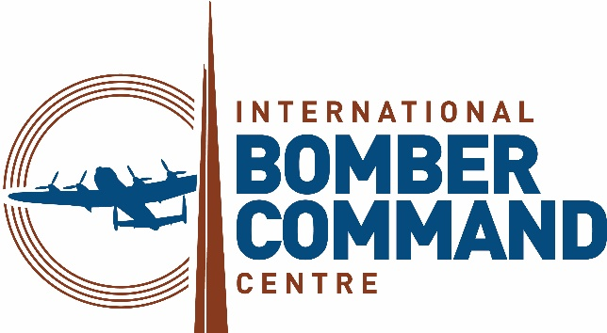

News Release

5th February 2026

IBCC to Commemorate WW2 Veteran’s 108th Birthday

World War Two RAF Bomber Command pilot Flt Lt Harry Richardson DFC will be honoured at a special event on Saturday 7th February to celebrate his 108th birthday.

Flt Lt Richardson, who is one of the oldest living WW2 veterans, along with his 82-year-old daughter Penny and distinguished guests will enjoy 1930’s music and dancing at the RAF Association Club in Prestwick, South Ayrshire, where Harry now lives.

On the night, representatives from the International Bomber Command Centre in Lincoln including volunteer Alaistair Montgomery, who served in 44 Squadron during Operation Black Buck, will present Harry with a record of his service history in recognition of his outstanding service to Bomber Command, the wider Royal Air Force and commercial aviation.

The biography contains details of his operational sorties between May 1941 and January 1945 in Europe with 149 squadron and in South-East Asia with 59 Squadron. It also features photos of Harry as a young boy, as a pilot and with his two brothers, Ken and Stan, who served in the RAF and the Royal Navy.

ACM Sir Michael Graydon GCB CBE, Former Chief of the Air Staff and Chair of International Bomber Command Centre, said it’s an honour to be able to celebrate Harry’s birthday in this way.

“Harry Richardson represents a body of people whose contribution to victory in World War Two was not recognised,” he said.

“The treatment of Bomber Command at the end of the war was shameful. It has been a privilege for us at the International Bomber Command Centre to help to rectify this failure and to have met such people as Harry.

“Happy birthday Harry, and thank you for all you did for the nation and for the freedom we enjoy today.”

Harry, who will turn 108 on 8th February, was inspired to become a pilot after watching Hawker Hurricanes taking off and landing at RAF Northolt during the summer of 1939. Soon after he completed his pilot training in Scotland before joining 149 Squadron at RAF Mildenhall. Harry and his crew took part in the first two 1,000-bomber raids and unlike so many, he survived two remarkable operational tours.

After completing 30 operational sorties in the European theatre, Harry took up an instructional role on the Avro Anson at RAF Lichfield. He then moved to the Far East where he completed another 32 operational sorties on the B24 Liberator. His longest mission was over 18 hours which, for a time, was the longest flown wartime mission.

After the war, Harry and his family moved to Prestwick, where he joined the National Air Traffic Service as an air traffic controller. He climbed through the ranks and played a key role in assisting in the planning of the Air Traffic Service over the Atlantic.

Among his many accolades are a Distinguished Flying Cross for his bravery and airmanship and the prestigious Provost’s Medal which recognises national or international achievement at the highest level for people who were born in, or are residents of, South Ayrshire.

During the VE Day 80 celebrations last year, he was honoured at events locally and nationally. He was also present at the VE Day 80 concert at Horse Guards Parade in London and had the honour of sitting next to their Majesties King Charles III and Queen Camilla.

Commenting on his distinguished career, Chief of the Air Staff Air Chief Marshal Sir Harv Smyth said: “Happy 108th birthday – what an amazing achievement! Thank you for your service in the RAF.

“Flying Wellingtons and Liberators in South-East Asia must have been the experience of a lifetime, perhaps only to be outdone by the fact that you managed to sit next to His Majesty the King during last year’s VE Day – right and proper too! From me and your RAF family, here’s wishing you a very happy birthday.”

To listen to an interview with Flt Lt Harry Richardon please visit the IBCC Digital Archive https://ibccdigitalarchive.lincoln.ac.uk/collections/document/58708
Ends

Notes to Editors

The International Bomber Command Centre, which opened on 30th January 2018, provides a world-class facility to serve as a point for recognition, remembrance and reconciliation for Bomber Command.

Since its opening the centre has welcomed over 730,000 visitors from 61 different countries, including over 35,000 schoolchildren through its learning programmes.

The centre has received 40 different awards for interpretation, innovation, ethical, sustainable and responsible tourism, international tourism, heritage and education, including the VisitEngland bronze award holder for Best Large Visitor Attraction and the holder of the King’s Award for Voluntary Services.

The IBCC has involved over 500 volunteers from nine countries who have supported every aspect of the extensive project.

Facebook and LinkedIn: InternationalBomberCommandCentre
X, TikTok and Instagram: @IntBCC

For further media information please contact:
Kate Strawson
Director
Shooting Star
kate@weareshootingstar.co.uk
07733 230293

