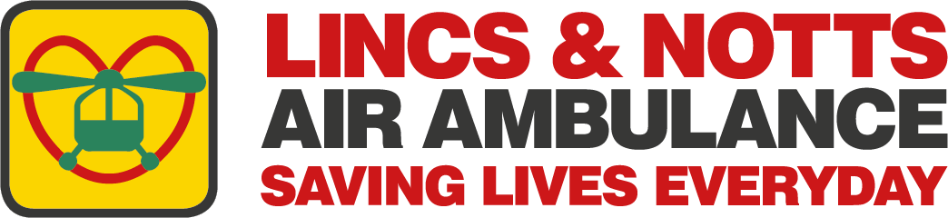

News release

8th June 2026

Could Your Team Win the Lincoln Dragon Boat Race?

The Lincs & Notts Air Ambulance (LNAA) is encouraging local businesses, sports clubs and community groups to take part in this year’s Lincoln Dragon Boat Festival and help raise vital funds for a second life-saving helicopter.

Now in its ninth year, the event on Saturday 11th July at the Brayford Waterfront is being organised by the LNAA as part of its Mission Possible 2 Appeal, in partnership with Ringrose Law.

With more than 18 teams already registered to compete in the 200-metre race on the Brayford Pool, the charity is now appealing for more teams to register before the deadline on 19th June.

They’re also looking for additional sponsorship including a Golden Dragon headliner sponsor.

Rachel Wilson, Head of Community, Corporate and Events, explained: “The Lincoln Dragon Boat Festival is one of our most exciting community events, bringing together businesses, families and friends for a fantastic day of fun, teamwork and friendly competition.

“Every team that takes to the water is helping us move closer to our goal of bringing a second helicopter to our skies which will enable us to reach around 400 additional patients every year.

“We're extremely grateful to everyone who has already signed up, either as a participant or a sponsor, but we’d love more local businesses, organisations, sports clubs, community groups or just groups of families and friends to get on board.

“For businesses the event offers a unique opportunity to get your company name in front of the hundreds of spectators and fellow participants who will be there on the day, all while raising vital funds to help us save more lives across Lincolnshire and Nottinghamshire.”

Alex Bennett, Head of Marketing at Ringrose Law, added: “Over the past decade, the Lincoln Dragon Boat Race has grown thanks to the incredible support of local businesses, charities, volunteers and the wider community.

“We are proud to be involved once again this year and have thoroughly enjoyed working in partnership with Lincolnshire & Nottinghamshire Air Ambulance as they prepare to take ownership of the event moving forward.

“The dragon boat race has always been about bringing people together, and it is fantastic to see so many businesses continue to get behind the event. We look forward to seeing it continue to thrive under the air ambulance's stewardship, raising vital funds and awareness for a charity that provides such an important service to our communities.”

Each team consists of 10 paddlers and one drummer, and no previous experience is required. Participants are encouraged to wear their own team branding or fancy dress, and all the necessary safety equipment and a full pre-race briefing will be provided.

Every team will also receive commemorative medals, while the winning crew will be awarded the coveted championship trophy!

Cargill PLC is entering a team for the first time.

Siân Green, Executive Assistant, said: “We’re proud to be entering a team into the LNAA Lincoln Dragon Boat Festival to support the incredible, lifesaving work the charity does across our rural communities.

“As a team, we are passionate about supporting local causes and as an agricultural business this felt like a perfect fit for us.

“We’ve put together a passionate (and very competitive) team who are ready to race, raise funds and hopefully make a splash on the leaderboard. We’re lucky to have Cargill’s support behind us, and we can’t wait for the big day. Bring on the paddles!”

This year every penny from the event will go towards the LNAA Mission Possible 2 Appeal which is aimed at raising the £500,000 needed to get a second helicopter in the air by late-summer 2027.

In addition to the boat race, there’ll be lots of activities for people of all ages to enjoy including balloon modelling, hook a dragon, face painting and even a human fruit machine!

Lincoln Rock Choir will be performing during the day, and the Odeon Cinema will be hosting a Family Zone between 10am and 4pm. There will also be a Dragon Trail around the city centre, with the chance to pick up a special discount booklet packed with vouchers from restaurants and hotels along the Brayford.

To enter a team or sponsor the Dragon Boat Festival please visit the LNAA website before 19th June.

Ends
Notes to Editors:

About the LNAA

The Lincs & Notts Air Ambulance (LNAA) is a leading Helicopter Emergency Medical Service (HEMS) charity providing world-class, pre-hospital critical care across Lincolnshire and Nottinghamshire. The service responds to the region’s most serious and life-threatening incidents.

Operating night and day, all year round, LNAA’s highly skilled teams of doctors, paramedics and pilots take the hospital to the patient, wherever they are. With crews equipped to deliver advanced interventions such as anaesthetics and emergency blood transfusions, patients have the best chance of survival.

And as a fully independent charity, the charity receives no government or NHS funding for its missions, relying solely on the generosity of supporters, partners and communities to stay operational.

With its state-of-the-art AW169 helicopter, LNAA continues to innovate and set the standard for critical care delivery, ensuring patients have the very best chance of survival during their greatest hour of need.

The crews cover an area of 3,500 square miles, serving a population of more than 2.5 million people.

About the Mission Possible 2 Appeal

Following a rise in demand for its services over recent years of 135%, the LNAA is raising £7m to pay for a second helicopter. This will enable crews to reach more patients faster, reduce missed callouts and give more people the best possible chance of survival.

The charity has already secured pledges and donations for most of the money needed and has booked its place on the production line. The Mission Possible 2 Appeal aims to raise the £500,000 needed to get the second helicopter in the air by late summer 2027.

The LNAA will then have two air ambulances that can get to any corner of Lincolnshire and Nottinghamshire in under 20 minutes.

How you can help:
- Donate at ambucopter.org.uk/mission-possible-2-appeal/
- Organise a fundraising event in your community
- Volunteer with LNAA

Together, we can ensure our life-saving service continues to be there for families across Lincolnshire and Nottinghamshire.

For media enquiries please contact:
Kate Strawson
Shooting Star
kate@weareshootingstar.co.uk
weareshootingstar.co.uk
01522 528540 / 07733 230293

