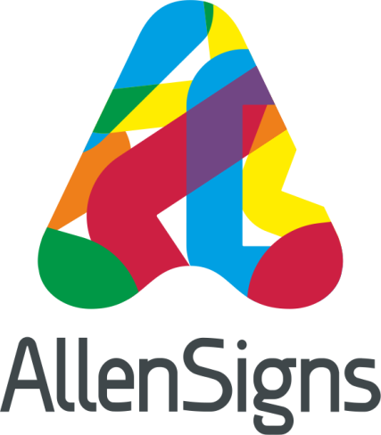

News Release
24th September 2015

Allen Signs Welcomes a New Account Handler to the Team

Sign maker and vehicle livery specialist Allen Signs has recruited a new account handler to its growing team.

Having recently acquired the printing division of Double Red and doubled the size of its premises, Allen Signs has taken on David Walker (30) to help manage the increased workload.

David commented: “Everyone has made me feel very welcome here. I have had a very busy first few weeks and I am learning new things about the business on a daily basis.

“I was attracted to my new role at Allen Signs because it gave me the perfect opportunity to move forward with my career, face new challenges and become part of a growing and ambitious business.”

David, who has always been based in Lincolnshire, has 13 years of industry experience and started his career at Chameleon Print in Lincoln. In his previous role he was more involved in the digital print side of the business. However, at Allen Signs, David’s day-to-day role is mainly client-focused, speaking to customers on a regular basis and putting together quotes.

“I am enjoying the diversity my new role has to offer,” added David, “and I hope it will help me to build upon the previous knowledge and experience that I have.”
Glen Merryweather, Sales and Marketing Manager at Allen Signs, said: “David has settled in very well with the team at Allen Signs. His enthusiasm and organisational skills are helping the sales team work together more efficiently as we undergo a wave of exciting changes.”

Allen Signs was set up in 1965 and this year celebrates its 50th Anniversary.

Managing Director David Allen said: “David joins us during what is an exciting and important year for the business as we’re not only expanding but also celebrating a major milestone.

“We’ve been through some challenging times over the past half a century, including three recessions, but we’re now enjoying the benefits of all that hard work having established ourselves as one of the leading sign makers and vehicles livery specialists in the East Midlands. David’s appointment will enable us to continue building on that success and I’m looking forward to seeing what the next 50 years have in store!”

Ends

Notes of Editors:

- Allen Signs was first established in 1965 by David Allen’s father Barry and has a head office on Whisby Way in North Hykeham, Lincoln and an office in Knight & Whitehall House on Carlton Street, Nottingham.
- The business provides a complete sign, display and vehicle livery solution from concept and design through to final installation and maintenance.
- To find out more about Allen Signs call 01522 501500, visit the website www.allen-signs.co.uk or follow them on Twitter @Allen_Signs

For more information about this news release please contact:
Kate Strawson
Shooting Star
Tel: 01522 528540

kate@weareshootingstar.co.uk
www.weareshootingstar.co.uk

