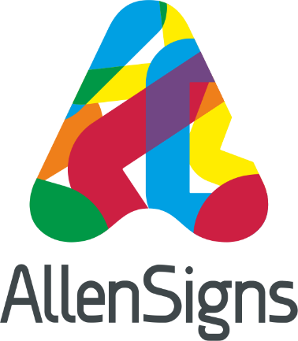
News Release
2nd August 2016

Allen Signs Creates a Splash at One NK

Sign and vehicle livery specialists Allen Signs have been making a splash at the new ONE NK sports centre in North Hykeham which has recently undergone a £3.6m refurbishment.

As part of the refit Allen Signs, which has offices in Lincoln and Nottingham, was commissioned to print and install artwork and signage designed by video, photography and animation production company Electric Egg.

This included internal artworks for the stairwells and around the swimming pool – the centrepiece being an impressive 29m by 3m wall mural which was unveiled by Olympic swimmer Sharron Davies MBE at the official opening in July.

Mike Lock, NKDC Leisure and Cultural Service Manager, said: “When Electric Egg, who brought together the artwork inspiration for ONE NK, told us they were bringing on board Allen Signs, we were absolutely delighted. Having worked with them in the past on various projects we knew they would bring the expertise needed to carry out such a difficult job.

“Their approach to work is impeccable and we knew that they would carry out the task to the highest standard. There are several pieces throughout the centre that showcase what the centre is about, as well as outdoor signage giving the once dated exterior a much more modern and welcoming vibe.

“They are such easy and outgoing guys, and will help wherever they can to get a job done. I couldn’t have asked to work with better people.”
Steve Hatton from Electric Egg added: “We were delighted to work with Allen Signs. Their skill and professionalism in surveying the site and installing the artworks was critical, allowing us to focus on the design and creation of the artworks.”

The new centre features of a variety of new facilities including a gym, dance and spinning studio, a café, the UK’s first interactive flume and a Magna Carta-inspired children's splash pool.

As well as printing and installing the artwork Allen Signs surveyed the site and specified the materials to be used to achieve the best possible result.

Glen Merryweather from Allen Signs said: “We’ve really enjoyed working with Neil and Steve at Electric Egg and Mike and the team at NKDC.

“Being involved in the project from the early stages through to the unveiling of ONE NK has been very satisfying and the wall graphics and signage seem to have been enthusiastically received by the council and visitors alike.”

Ends

Notes to Editors:

- Allen Signs was first established in 1965 by David Allen’s father Barry and has a head office on Whisby Way in North Hykeham, Lincoln and an office in Knight & Whitehall House on Carlton Street, Nottingham.
- The business provides a complete sign, display and vehicle livery solution from concept and design through to final installation and maintenance.
- In July 2015 Allen Signs bought the printing division of Double Red which now operates independently under the slightly modified name of Double Red Print Limited.
- To find out more about Allen Signs call 01522 501500, visit the website www.allen-signs.co.uk or follow them on Twitter @Allen_Signs
- Electric Egg was formed by Neil Baker and Steve Hatton in 2005 to offer innovative video, photographic and animation services.

For more information about this news release please contact:
Kate Strawson
Shooting Star
Tel: 01522 528540
kate@weareshootingstar.co.uk
www.weareshootingstar.co.uk

