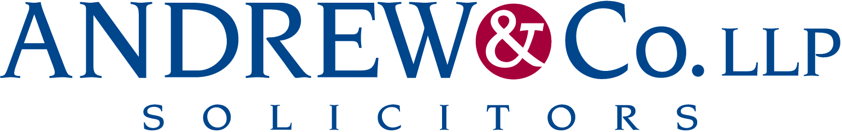

News Release

14th April 2015

Switch On to the Andrew & Co Energy Forum

Following the success of its inaugural Excellence in Energy Forum, Andrew & Co LLP is inviting industry leaders to its second quarterly dinner on 23rd April 2015.

The meeting is aimed at encouraging people working in the sector to get together to network, share ideas and discuss any issues affecting the industry.

Organiser and head of the renewables team at Andrew & Co LLP Helen Bell explained: “We have been working with a range of businesses in the energy industry for quite some time now and our in-house experts have a great depth of knowledge.

Both green and renewable energy are becoming an increasingly important across all sectors and in June last year, Andrew & Co LLP and Lincolnshire Media jointly hosted the first Lincolnshire Energy Awards.

“This year we are proud to be sponsoring the awards once again and have also set up the forum to give key industry players the chance to meet up and talk about their areas of expertise and how they can continue to grow in the future.

“The first forum in January was very well attended and we look forward to seeing some familiar faces and meeting some new ones at the second event later this month.”

As well as a three-course meal, the quarterly forums will also have a guest speaker. CEO and Managing Director of Lindhurst Engineering Martin Rigley will give an informative talk at the forthcoming event at DoubleTree by Hilton Lincoln.

Martin founded the business, which initially provided services to the UK mining market, in 1985. More recently the company has focused on green technologies, in particular biomass digestion units used to produce gas from a new form of anaerobic digestion which offers increased efficiency and a reduced physical footprint.

The Excellence in Energy Forum dinner at the DoubleTree by Hilton Lincoln on 23rd April will get under way at 6pm. The cost to attend is £37.50 per person. Anyone interested should contact Chris Brown at Andrew & Co LLP on 01522 512123 or email chris.brown@andrew-solicitors.co.uk

Ends

Notes to Editors

- This is not legal advice; it is intended to provide information of general interest about current legal issues.
- Andrew & Co LLP is one of the longest established independent law firms in the East Midlands, having been set up in 1832.
- It offers a comprehensive range of legal services to private individuals and businesses across a wide range of sectors including renewable energy, agriculture, personal injury, conveyancing, charity and not-for-profit, family and employment law.
- Andrew & Co has 60 staff based at its offices in on Nettleham Road in Lincoln and Kirkgate in Newark.
- The Law Society is the representative body for more than 145,000 solicitors in England and Wales ('the Society'). The Society negotiates on behalf of the profession, and lobbies regulators, government and others.

For more information contact:
Kate Strawson
Shooting Star PR
07733230293

