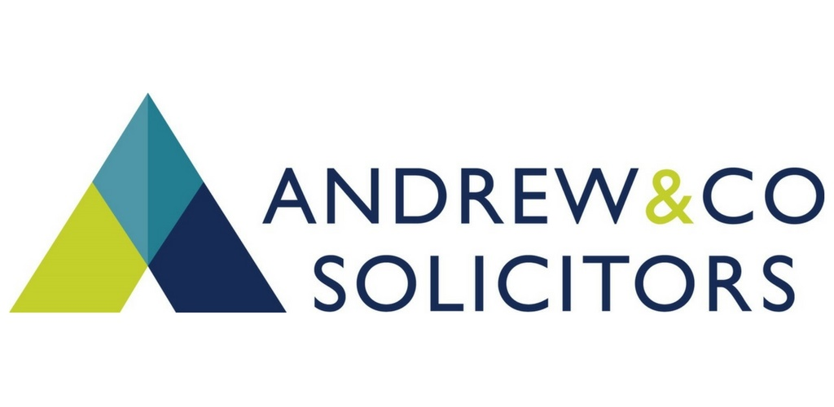
News Release
15th September 2017

Andrew & Co Solicitors Bolsters Commercial & Corporate Team

Andrew & Co Solicitors has strengthened its Corporate & Commercial team with the appointment of three new legal experts.

Paul Simpson has joined the team as Associate Solicitor along with paralegal Elliot Varnam and Natalia Fryda, who started working at the firm in 2014 as a trainee and is due to qualify as a solicitor on 2nd October.

Paul, who lives in Newark, was previously a director at the Nottingham office of a national law firm and has worked in corporate law for over 15 years. He has acted for a range of clients including individuals, partnerships, management teams, private equity funds, banks and investors.

The 43-year-old has experience in a broad range of corporate matters including management buy-ins and buyouts, acquisitions, disposals, shareholder and joint venture arrangements and partnership agreements.

He has also worked on several high-profile jobs including the sale by Steeper Group of its
Bebionic Division to German prosthetics company Otto Bock and the management buyout of the NEC Group.

“I enjoy building a relationship with my clients so that I can become their first point of call whenever they require legal advice,” said Paul. “It’s my job to ensure that when they make commercial decisions, they can do so informed of the relevant legal matters.”

Explaining what attracted him to the job, Paul added: “Andrew & Co Solicitors is an established firm which is enjoying continued growth in Lincolnshire and Nottinghamshire. I’m looking forward to helping Helen Bell and the rest of the team build on the solid reputation Andrew & Co has as one of the county's most highly regarded corporate practices.”

Paul’s colleague Natalia Fryda joined Andrew & Co after graduating from the University of Lincoln in 2014. Natalia has spent time working in several different teams, building her experience as a trainee, and will now be focusing her expertise on supporting clients with corporate and commercial matters. Her responsibilities include dealing with the due diligence and disclosure aspects of purchasing, selling and merging businesses.

Elliot Varnam joined Andrew & Co Solicitors as a paralegal in July 2017, having recently completed a law degree at the University of Lincoln. Before going to university, Elliot lived in Abu Dhabi where he managed to gain work experience placements with international law firms.

His role includes assisting Head of Corporate & Commercial Helen Bell and the rest of the team to ensure clients’ transactions proceed as smoothly as possible.

Commenting on the new appointments Helen said: “I am delighted to welcome Paul, Natalia and Elliot to the team and wish them every success in their new roles. We now have one of the largest corporate legal teams in Lincolnshire and Newark and I don't think there are many other firms in the region who have such a strong and knowledgeable team.”

Ends

Notes to Editors
- Andrew & Co Solicitors is one of the longest established independent law firms in the East Midlands, having been set up in 1832.
- It offers a comprehensive range of legal services to private individuals and businesses across a wide range of sectors including renewable energy, agriculture, personal injury, conveyancing, charity and not-for-profit, family and employment law.
- Andrew & Co has 60 staff based at its offices in on Nettleham Road in Lincoln and London Road in Newark.

For more information, contact:
Kate Strawson
kate@weareshootingstar.co.uk
Shooting Star
weareshootingstar.co.uk
01522 528540
07733 230293

