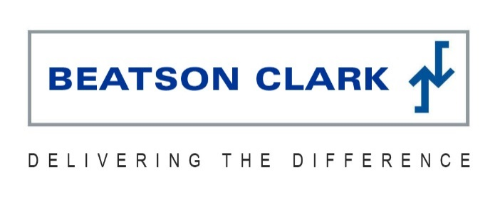
News release

3rd June 2016

Beatson Clark Causes a Stir with Cocktail Jam Jars

Cocktails and mixology are all the rage, and the hippest cocktail bars are now serving drinks in teacups, fish bowls, coconuts – anything other than a cocktail glass!

Now leading glass manufacturer Beatson Clark is capitalising on the trend by providing a 300ml food jar for a range of ready-to-serve premium cocktails.

London Rd Jam Jar Cocktails is a range of authentic flavours, including Mojito, Cosmo and Singapore Sling.

Each recipe has been developed by expert mixologists with a spin on the classics and packaged in Beatson Clark recyclable jam jars featuring label designs bespoke to each flavour.
The Cosmo label features the night-time silhouette of the New York sky line, the Mojito takes its design cues from Cuba while the Singapore Sling captures the sun rising over the garden city.
London Rd Jam Jar Cocktails have been launched by Global Brands, the UK’s leading independent drinks business, and are proving popular with consumers who enjoy the taste of an authentic cocktail at home as well as bar operators experiencing operational time constraints.
Simon Green, Marketing Director at Global Brands, said: “London Rd Jam Jar Cocktails celebrate the role that London played in the early cocktail scene. Long considered an American invention, there is evidence to suggest that the cocktail’s roots can actually be traced back to 18th-century London.
“The key with any great cocktail is to ensure that every flavour plays its part. London Rd Jam Jar cocktails were developed with painstaking care to ensure that the real cocktail flavour can be delivered in a ready-to-drink format.”

Charlotte Taylor, Marketing Manager at Beatson Clark, commented: “Our partnership with Global Brands exemplifies the flexibility of our approach. We have an extensive and versatile range of shapes and sizes available from stock, and while our 300ml food jar was designed primarily for jams and chutneys its simplicity and sleek lines work perfectly with the contemporary look of these stylish cocktails!

“We had the cocktail jars on display at Food & Drink Expo last month and they proved very popular with visitors to our stand. Serving cocktails in jars is a huge trend at the moment and we were very pleased to be able to help Global Brands with their innovative and creative product idea.”

Catherine Roddis, Global Brands Purchasing Manager said: “When choosing a jar supplier for this innovative new product, I immediately thought of Beatson Clark as I knew I could rely on their excellent customer service and professionalism.

“Having used Beatson Clark for a number of years to supply other products in our portfolio I was confident the quality and clarity of the glass would be excellent. The company have been accommodating and helpful in going the extra mile to meet our increasing demand as well as being competitively priced.”
Ends
Notes to editors:

- Beatson Clark specialises in providing glass packaging solutions for niche brands in the food, drink and pharmaceutical markets worldwide. The key to its success has been flexibility, innovation and the high quality of its containers.
- Beatson Clark’s customers are at the core of its business and the company is proud of the long-standing partnerships it has developed thanks to the outstanding level of service it offers.
- Beatson Clark has a turnover of £44 million and a production capacity of approximately 496 million units or 88,000 tonnes.
- It has ISO 9001:2000, BRC/IOP Food Packaging Hygiene Standard and OHSAS 18001:1999 Occupational Health & Safety Standard and its manufacturing capability has an emphasis on flexibility to facilitate short tailored production runs. It has a UK distribution centre located in Rotherham.
- Global Brands is one of the UK’s leading drinks brand development businesses which owns, markets and distributes a range of brands across the spirit, beer, ready-to-drink and energy drink categories.
- Its brands include VK, Hooch, Hooper’s, Kick Start and Amigos Tequila Beer.
- Global Brands formed in 1997 and now export to over 30 countries around the world including France, Canada and Japan.
- For more information visit www.globalbrands.co.uk
For media information contact:
Jez Ashberry
Shooting Star
01522 528540
jez@weareshootingstar.co.uk
@jezashberry
[beatsonclark76cocktails]

