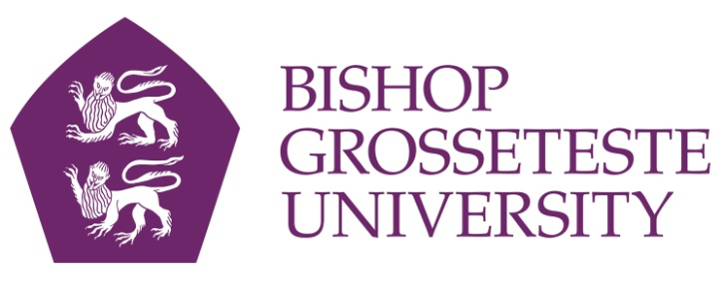
News release

1st December 2014

BGU Academic Elected to Children’s Spirituality Role

An academic at Bishop Grosseteste University in Lincoln has been elected Vice-Chair of the International Association for Children’s Spirituality (IACS).

Dr Kate Adams, Reader in Education at BGU, has been researching and publishing on the topic for 15 years.

The IACS promotes research and practice in children's spirituality and has members in 16 countries.

Ofsted currently inspects schools’ provision for pupils’ spiritual, moral, social and cultural development, and if it finds weaknesses in this provision a school will be judged to require improvement or be rated inadequate.

“Most academics in the field agree that schools’ recognition of children’s spiritual life is extremely important at this point in history, when many teachers feel overwhelmed by targets, exam results, league tables and inspections,” said Kate.

“However, variable provision in initial teacher training and continuing professional development can mean that many teachers have not been fully informed about children’s spirituality, leading them to miss the richness of this dimension of children’s lives.

“This is worrying, because without the appropriate grounding, adults can underestimate young people’s ability to explore and express their sense of self. In a busy classroom it is too easy to miss the fascinating ways in which children seek meaning and purpose in their lives and find their place in the world.”
Kate has recently secured a grant from the British Educational Leadership, Management and Administration Society to explore the key leadership qualities which help primary schools to be outstanding in relation to children’s spiritual, moral, social and cultural development (SMSC).

“If we can capture those specific leadership qualities, this knowledge and understanding can be used to support schools who find it difficult to achieve effective SMSC throughout their curriculum, thereby benefiting more children,” said Kate.

Members of the International Association for Children’s Spirituality across the world collaborate to help educators and other professionals understand this compelling dimension of children’s lives.

“As Vice-Chair I’m looking forward to working with international colleagues in developing the association in meeting these aims,” Kate added.

Notes to editors:

- Dr Kate Adams is Reader in Education and leads the Doctor in Education (EdD) programme at Bishop Grosseteste University. She is also an experienced primary teacher and author of over 40 articles and book chapters on aspects of childhood spirituality. Her books include Unseen Worlds: Looking through the lens of childhood and the co-authored The Spiritual Dimension of Childhood, both published by Jessica Kingsley.
- To learn more about the International Association for Children’s Spirituality visit the website: www.childrenspirituality.org
- Bishop Grosseteste University was established in January 1862 and celebrated its 150th anniversary in 2012.
- It is an independent higher education institution based in Lincoln which awards its own undergraduate and postgraduate degrees.
- It changed its name from Bishop Grosseteste University College to Bishop Grosseteste University in November 2012.

For media information please contact:
Jez Ashberry
Shooting Star PR
01522 528540
07780 735071
jez@shootingstar-pr.co.uk
[BGU118IACS]

