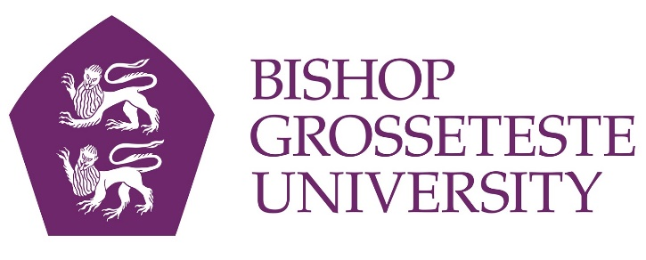

News release
29th September 2015

Lincoln B&B Featured in National Campaign

A bed and breakfast based on campus at Bishop Grosseteste University has been featured in a national newspaper as part of Visit England’s Access for All campaign.

Visit England has been working with the Daily Express to highlight accessible tourist and business destinations across the country. Longdales House bed and breakfast at BGU was featured in a special edition which appeared in the S magazine supplement on Sunday (27th September).

Visit England has now been granted an extra £125,000 to support businesses in improving their accessibility. As part of the project, businesses are provided with personalised feedback of their access statement as well as online and classroom disability awareness training for members of staff.

Located on the campus of Bishop Grosseteste University, Longdales House was originally home to the head of the college and in 2011 it was developed into a stylish bed and breakfast facility.

Staff at Longdales House have undergone extensive training over the past year to improve customer service excellence, having already attended a course as part of the World Host programme in June this year when Lincoln became a World Host committed destination.

Jane Vincent, Senior Conferencing and Events Co-ordinator at BGU, said: “I am delighted that Longdales House has been approved for inclusion in the Visit England National Access for All campaign. I would like to say thanks to all the BGU staff that have helped us to achieve these awards.”

Longdales House features a range of facilities for disabled people with accessible en suite rooms, conference rooms installed with hearing loops on the adjacent BGU campus, Deafgard alarm systems and a host of other options available on request.

Notes to Editors:
- Bishop Grosseteste University was established in January 1862 and celebrated its 150th anniversary in 2012.
- It is an independent higher education institution based in Lincoln which awards its own undergraduate and postgraduate degrees.
- It changed its name from Bishop Grosseteste University College to Bishop Grosseteste University in November 2012.

For media information please contact:
Jez Ashberry
Shooting Star
01522 528540
07780 735071
@ShootingStarPR
[BGU152accessible]

