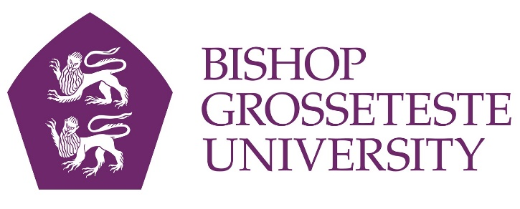

News release
27th October 2015

Trainee Teacher Navigates Path to the Classroom

She’s flown sorties in a Tornado jet over Iraq and Afghanistan, but after ten years in the RAF trainee teacher Jenny Shackley is now taking on a very different kind of challenge.

Jenny (31) from Woodhall has just started a one-year postgraduate course at Bishop Grosseteste University in Lincoln and hopes to be teaching maths in a Lincolnshire secondary school this time next year.

It’s a far cry from her role as a Tornado navigator, but the mathematics she used in the RAF helped her decide to train as a maths teacher.

Now she wants to put down roots and work with young people, and she’s won a £25,000 scholarship from the Institute of Mathematics and its Applications (IMA) to help her achieve her goal.

“I was in the RAF for ten years from 2003 to 2013 and did three tours of Afghanistan and two tours of Iraq,” says Jenny, whose partner is also a Tornado navigator currently based at RAF Coningsby.

“I spent lots of time away and now I want to settle down and work with people so I decided to go into teaching.

“I wanted to be a teacher first and foremost; maths is a subject I enjoyed at school but I didn’t have a lot of self-belief. However I used it a lot in the RAF, and that’s given me more confidence with the subject.”

With a mortgage and bills to pay Jenny looked round for bursaries, but then found out she was eligible for the IMA’s scholarship which exists to promote good mathematics teaching in schools.

She passed the rigorous three-stage application process with flying colours and now benefits from membership of various mathematical bodies as well as access to events and a network of scholars with whom she can share ideas.

“I definitely wouldn’t be doing this course if I hadn’t got the scholarship,” said Jenny. “I needed some sort of income so I was delighted when I found out that my application was successful.”

With an open degree from the Open University Jenny began looking for teacher training courses in Lincolnshire, and she soon decided that a place at BGU was for her.

“I’m very happy that I came to BGU,” she said. “I get a sense that this university is a very positive place and I definitely got a good feeling as soon as I walked onto campus.

“From day one I’ve been given all the information I need and it feels like a place I can work in and feel I’m being treated well. Our tutors have given us a strong sense of ownership of the course. I think it’s a really good environment.”

If you would like to find out more about BGU’s teaching courses, including the PGCE (Secondary) qualification, call Admissions on 01522 527347 or email admissions@bishopg.ac.uk.

Notes to Editors:
- Bishop Grosseteste University was established in January 1862 and celebrated its 150th anniversary in 2012.
- It is an independent higher education institution based in Lincoln which awards its own undergraduate and postgraduate degrees.
- It changed its name from Bishop Grosseteste University College to Bishop Grosseteste University in November 2012.

For media information please contact:
Jez Ashberry
Shooting Star
01522 528540
@ShootingStarPR
[BGU155jennyshackley]

