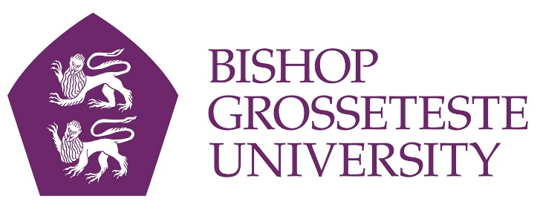

News release

27th January 2016

City Universities to Clash in Historic Football Match

Lincoln’s two universities will do battle on the football pitch in a new challenge cup competition next month.

The inaugural Cathedral Cup match between Bishop Grosseteste University and the University of Lincoln will take place on Wednesday 10th February under lights at Sincil Bank, home of Lincoln City FC.

Organisers hope the game will become an annual fixture.

“The footballing gap between the two universities has significantly reduced over recent years, and the University of Lincoln's first team were impressed by our standard this year, so we decided to stage the first competitive fixture between the two universities,” said Callum Ward, President of the BGU Football Society and a former youth team player at Lincoln City.

“This game will hopefully develop into an annual fixture and be the students' sporting spectacle that the city craves so much!

“We aspire to get as many people in attendance as possible because it will be an unforgettable event for all involved,” Callum added.

Dr Graham Basten, Head of the School of Social Sciences at BGU, commented: “We’re looking forward to the match next month, which will be a coming of age for our rapidly improving football team.

“The fixture will also be an opportunity to showcase our partnership with Lincoln City, which goes far beyond shirt sponsorship and provides opportunities for engagement between the club and our students at many different levels.

“We work closely with Lincoln City on a number of initiatives, including Football in the Community work, placement opportunities for BGU students and partnerships between the football club and BGU's sports courses.
“We also work with the Lincoln City Sport and Education Trust to support its work with children and young people in the local area.”

University of Lincoln’s Men’s Football President Will Fry added: “It’s taken a lot of hard work by me, Callum Ward and Lincoln City. We are looking forward to a huge event that will hopefully become an annual fixture and draw the students and the city closer together.

“It’s huge for the football club to run what has the potential to be the biggest student event in the city.”

The match will kick off at 7.45pm on Wednesday 10th February at Sincil Bank. Tickets cost £3 and are available at the Students’ Union at both universities.

Bishop Grosseteste University

- Bishop Grosseteste University was established in January 1862 and celebrated its 150th anniversary in 2012.
- It is an independent higher education institution based in Lincoln which awards its own degrees at foundation, undergraduate and postgraduate level.
- It changed its name from Bishop Grosseteste University College to Bishop Grosseteste University in November 2012.
- BGU has over 2,300 students, including undergraduate, postgraduate and research, with over 280 students at collaborative partners across Lincolnshire.
- In 2015 BGU was the second highest ranked university in the UK for employability with almost 99% of our leavers in work or study six months after graduating (2013/14 DLHE).
- BGU is a main club sponsor and the home shirt sponsor of Lincoln City FC and has has its own sports and leisure facilities as well as a cinema (The Venue) on campus, all open to the public.

University of Lincoln

- The University of Lincoln was named among the UK's best modern universities in the Times and Sunday Times Good University Guide 2016. It has some of the most satisfied students in the UK, rating in the top 25% nationally in a number of subject areas of the National Student Survey 2015 with Psychology ranked number one.
- It is recognised for its pioneering approach to working with employers, winning a Lord Stafford Award and a Times Higher Education Award. Graduate prospects are strong with nine out of ten of Lincoln’s most recent graduates in work or further study six months after finishing their course.
- In the Research Excellence Framework 2014, more than half of our submitted research was judged to be internationally excellent or world leading, with Lincoln ranked in the UK’s top 10 for quality of research outputs in two major subject areas.

For media information please contact:
Jez Ashberry
Shooting Star
01522 528540
07780 735071
jez@weareshootingstar.co.uk
[BG162cathedralcup]

