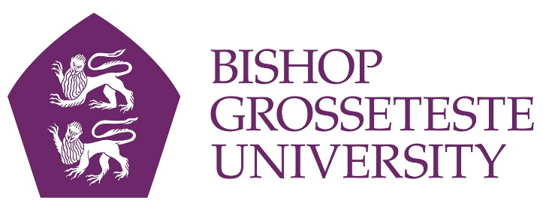

News release

2nd February 2016

Find Out About Volunteering at BGU

Volunteering to help others is not just personally rewarding – it can also help you develop skills that are invaluable to potential employers.

To help students and others to learn more about volunteering, Bishop Grosseteste University in Lincoln is to host a Volunteering Fair on Wednesday 10th February 2016 which will also be open to the public.

More than 20 organisations will attend the event from 12.30pm until 3pm in the Students’ Union at the BGU campus on Longdales Road in Lincoln. Organisers hope to raise awareness of the value of volunteering while also opening up volunteering to those who may not have previously considered it.
“Volunteering is a fantastic way to support good causes and it's also a great way to kick start a career, improve your CV and get active in the wider community,” said BGU’s Volunteering and Opportunities Officer, Lucy Camsell.

“Almost half of all people in England do voluntary work, and more than a quarter volunteer once a month, according to a survey conducted last year by the Institute for Volunteering Research.”

Information will be available on a wide range of volunteering opportunities including befriending and mentoring, environmental conservation, fundraising and campaigning and health and social welfare.

Steph Boyfield, Project Officer at Voluntary Centre Services in Sleaford which is exhibiting at the event, said: “Many people find that helping out in the community leads to changes in their own lives, such as a career change, new friends or an improved sense of wellbeing.

“There are many opportunities to help out, depending on what you’re into. There are lots of roles that look for personal qualities such as a caring nature, good listening skills or practical experience as well as relevant qualifications, and many are flexible too, fitting in around other commitments such as work, family or studies.”

She added: “Although volunteering for a local charity or community group isn’t paid, there are other benefits. Volunteering can unlock your potential and tap into qualities and skills you didn’t even realise you had, boosting self-esteem and even enhancing your CV.

“Research says that doing good actually does you good, improving both mental and physical health and contributing to a more positive community – an all round win!”

For further information contact Diane Haines on 01522 583900 or email diane.haines@bishopg.ac.uk.

Notes to editors:

- Bishop Grosseteste University was established in January 1862 and celebrated its 150th anniversary in 2012.
- It is an independent higher education institution based in Lincoln which awards its own degrees at foundation, undergraduate and postgraduate level.
- It changed its name from Bishop Grosseteste University College to Bishop Grosseteste University in November 2012.

For media information please contact:
Jez Ashberry
Shooting Star
01522 528540
07780 735071
jez@weareshootingstar.co.uk
[BG163volunteeringfair]

