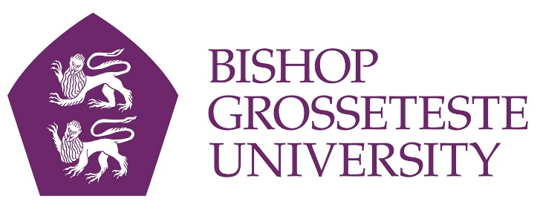

News release

18th March 2016

BGU Barista is Full of Beans

Making an excellent espresso or a classy cappuccino is all in a day’s work for Dominic Desforges, who will be pitting his barista skills against the best next week.

Dominic (23), who works as a barista at the Curiositea café at Bishop Grosseteste University, has been selected to compete in the Barista Skills Challenge at this year’s TUCO Competitions at Warwick University on Monday 21st and Tuesday 22nd March.

The 15-minute live competition will test the candidates’ skills in producing espresso, cappuccino and their own signature drinks which they have to discuss and present as they prepare them.

Dom recently attended an advanced barista development course in Bologna, Italy, and will be up against 27 other top baristas from universities across the UK.

“I’ve been a barista for four years but I wasn’t very good at it when I first started,” he said. “My boss at The Showroom in Lincoln could do a pattern on top of the coffee, which intrigued me, so I started practising and went to different cafés to see how it was done.

“To be a good barista you need interest and dedication as there’s a lot of science and hard work behind it.”

Next week’s event will be the first barista competition Dominic has taken part in.

“I’m feeling fairly confident but also a bit nervous about it,” he said. “For my speciality drink I’ll be making a chilled cocktail stretched with a simple syrup with hints of lemon and orange, so I hope it goes well!”

John Hodson, Operations Manager at BG (Lincoln) Ltd, added: “We are really thrilled that Dom will be representing us at this years’ TUCO competitions - good luck Dom, give it your best!”

Curiositea is Bishop Grosseteste University’s Alice in Wonderland themed café on campus which is open to the public.

TUCO is the leading professional membership body for in-house caterers operating in the higher and further education sector.

Notes to Editors

- Bishop Grosseteste University was established in January 1862 and celebrated its 150th anniversary in 2012.
- It is an independent higher education institution based in Lincoln which awards its own degrees at foundation, undergraduate and postgraduate level.
- It changed its name from Bishop Grosseteste University College to Bishop Grosseteste University in November 2012.
- BGU has over 2,300 students, including undergraduate, postgraduate and research, with over 280 students at collaborative partners across Lincolnshire.
- In 2015 BGU was the second highest ranked university in the UK for employability with almost 99% of our leavers in work or study six months after graduating (2013/14 DLHE).

For media information please contact:
Jez Ashberry
Shooting Star
01522 528540
07780 735071
jez@weareshootingstar.co.uk
[BG166barista]

