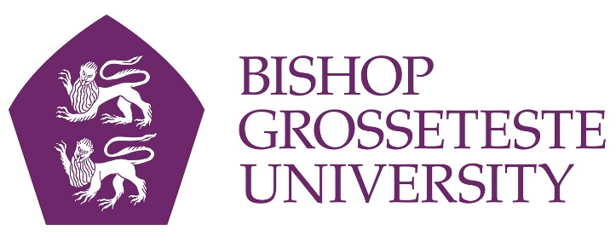

News release

17th March 2016

Eye-opening trip to India for BGU’s Theology Students

Fourteen theology students from Bishop Grosseteste University and three members of staff have just returned from the university’s latest visit to India.

The aim of the 2016 Theology Trip was to experience Indian religion and culture at first hand, supporting modules on the degree course which reference Asian beliefs and culture.

Because many of the students plan to be teachers the group also visited schools and universities, including those linked to BGU in a formal partnership.

The students also spent some time working with students from three colleges in the Tirunelveli area with which BGU has formal links: St John's College, St John's College of Education and Sarah Tucker College.

“These visits to India provide our students with a direct experience of Indian religion and culture, which they have studied in lectures and texts at BGU but which they need to actually experience in order to fully understand,” said Mark Plater, Lecturer and Subject Co-ordinator for PGCE Secondary Religious Education at BGU.

“Our visits include first-hand experiences of religion in the community and culture and visits to a range of educational contexts, including local and international schools, centres for special needs and higher education institutions.

“Apart from the more obvious educational benefits, these experiences also confront students with the challenges of developing countries, encouraging them to consider bigger questions about what is most significant in life and the limits of our own habits and assumptions.”

The annual visit took place from 23rd February until 3rd March 2016. Highlights included being blessed by an elephant at Meenakshi Temple in Madurai, visiting the children at SDETland, and spending time with Indian students in Tirunelveli.

Notes to Editors

- Bishop Grosseteste University was established in January 1862 and celebrated its 150th anniversary in 2012.
- It is an independent higher education institution based in Lincoln which awards its own degrees at foundation, undergraduate and postgraduate level.
- It changed its name from Bishop Grosseteste University College to Bishop Grosseteste University in November 2012.
- BGU has over 2,300 students, including undergraduate, postgraduate and research, with over 280 students at collaborative partners across Lincolnshire.
- In 2015 BGU was the second highest ranked university in the UK for employability with almost 99% of our leavers in work or study six months after graduating (2013/14 DLHE).

For media information please contact:
Jez Ashberry
Shooting Star
01522 528540
07780 735071
jez@weareshootingstar.co.uk
[BG167indiatrip]

