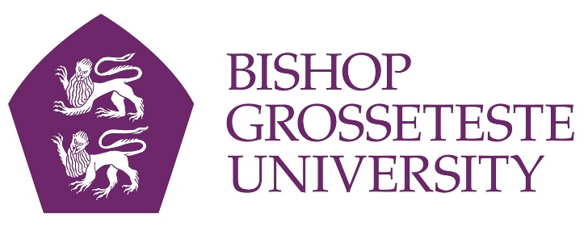
News release

11th May 2016

Dementia-Friendly Movie at The Venue

We all have a favourite film where classic one-liners and the musical score create a sense of nostalgia. Cinemas can provide a powerful way for those living with dementia to reconnect with their memories.

Now Lincoln cinema The Venue at Bishop Grosseteste University is working in partnership with the Lincoln Alzheimer's Society to show a dementia-friendly screening of Singin’ in the Rain on Wednesday 18th May.

The screening coincides with Dementia Awareness Week (15th to 21st May) and BGU is promoting this film as being particularly suitable for people affected by dementia and their partners, family and carers.

Among the benefits for viewers are increased lighting in the auditorium, reduced sound levels and no adverts or trailers preceding the fim.

Jane Vincent, Senior Conferencing and Events Officer at BGU, said: “Dementia-friendly cinema will be a great addition to our programme and sits alongside our Relaxed Screenings, which take place one Sunday per month.

“These special performances, planned and delivered in conjunction with the Alzheimer's Society and Grantham Autism Information Network, have subtle changes to the cinema environment which mean that people who have sensory difficulties have a more positive experience than they would in a traditional cinema setting.”

Tickets for the dementia-friendly film cost £4.50 and carers can go for free. You can purchase your tickets via www.thevenuelincoln.co.uk

Notes to Editors

- Bishop Grosseteste University was established in January 1862 and celebrated its 150th anniversary in 2012.
- The Venue, which boasts a digital projection system and surround sound opened in September 2012.
- BGU is an independent higher education institution based in Lincoln which awards its own degrees at foundation, undergraduate and postgraduate level.
- It changed its name from Bishop Grosseteste University College to Bishop Grosseteste University in November 2012.
- BGU has over 2,300 students, including undergraduate, postgraduate and research, with over 280 students at collaborative partners across Lincolnshire.
- In 2015 BGU was the second highest ranked university in the UK for employability with almost 99% of leavers in work or study six months after graduating (2013/14 DLHE).
- To learn more about Bishop Grosseteste University visit www.bishopg.ac.uk

For media information please contact:
Jez Ashberry
Shooting Star
01522 528540
07780 735071
jez@weareshootingstar.co.uk
[BG173dementia]

