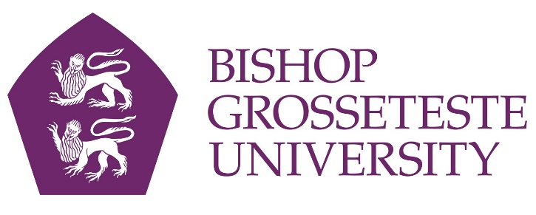
News release

18th July 2016

Student Overcomes Illness to Achieve Degree

Charlotte Pottage always knew she wanted to be a secondary school English teacher, and she refused to let illness and looking after her family get in the way of graduating from Bishop Grosseteste University this Thursday.

Charlotte, 22, was diagnosed with ME (chronic fatigue syndrome) just five months before she was due to start her Secondary English PGCE course at BGU in September 2015.

The decision to attend university surprised many of Charlotte’s peers. “When I told my occupational therapist my plans she simply raised her eyebrows,” Charlotte said.

In 2013 Charlotte’s mother Toni was left with health issues following a brain haemorrhage. This prompted Charlotte to make the difficult decision to move home to Scunthorpe after three years of living independently while she did her undergraduate degree in English at Leeds Trinity University.

Charlotte continued to care for her mother and two younger siblings throughout the duration of the course.

“My day consisted of making sure my sister got to school with a clean uniform and her hair tied up before taking care of myself,” said Charlotte. “After the day at school I would come home, prepare dinner and clean the house, then I would visit my mum in hospital every single day.”

Despite the huge responsibility of juggling caring for a family and a degree, Charlotte would use her evenings to study and ensure every assignment was handed in on time.
She is now working at Outwood Academy in Brumby, Scunthorpe as a full-time English teacher, and achieved outstanding results across all of her standards.

Charlotte added: “I have had to work harder than I ever imagined to get to the place where I am now, but I am so proud to have achieved what I have.”

Charlotte will receive her PGCE on Thursday 21st July at 10.15am at Lincoln Cathedral.

Notes to editors:
- Bishop Grosseteste University was established in January 1862 and celebrated its 150th anniversary in 2012.
- It is an independent higher education institution based in Lincoln which awards its own degrees at foundation, undergraduate and postgraduate level.
It changed its name from Bishop Grosseteste University College to Bishop Grosseteste University in November 2012.
BGU has over 2,300 students, including undergraduate, postgraduate and research, with over 280 students at collaborative partners across Lincolnshire.
- In 2015 BGU was the second highest ranked university in the UK for employability with almost 99% of leavers in work or study six months after graduating (2013/14 DLHE).
- To learn more about Bishop Grosseteste University visit www.bishopg.ac.uk

For media information please contact:
Jez Ashberry
Shooting Star
01522 528540
07780 735071
jez@weareshootingstar.co.uk
[BGU184gradcharlottepottage]

