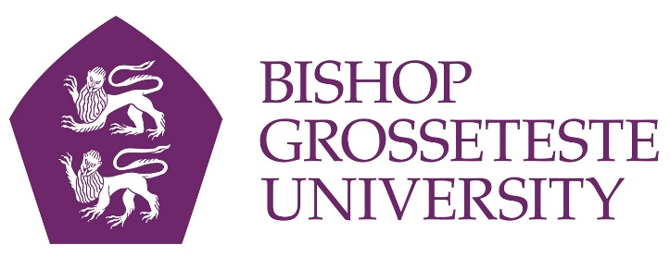

News release

19th September 2016

Universities to Battle it Out in Cathedral Cup Return

The date has been set for the much anticipated re-match of Bishop Grosseteste University and the University of Lincoln in the city’s annual Cathedral Cup football fixture.

While the inaugural fixture was won by UoL 6-1, BGU is hoping to stage a triumphant comeback on Wednesday 5th October at Sincil Bank. The match will kick off at 7.45pm in front of what is to be expected to be a very large crowd – the previous match attracted 1,300 spectators.

The two universities are set to compete not only on the football pitch, but also in a wider range of events including badminton, futsal and netball, all of which will take place earlier that day.

Callum Ward, President of the BGU Football Society and a former youth team player at Lincoln City, commented: “I am absolutely delighted to see the Cathedral Cup return. Last year's event won multiple awards and received fantastic feedback but the most pleasing aspect was how it engaged and appealed to students and the wider community from non-sporting backgrounds.
“When creating the event last year, we wanted to ensure the Cathedral Cup was sustainable and had the potential to grow and develop year on year. We have managed to do so with the introduction of other sports playing during the afternoon, by securing sponsorship from local companies, and by including more societies in the ticket-selling process.
“The most pleasing aspect for me is the wider impact of the event. It isn't just a football match; for example, students from the media department of the University of Lincoln are responsible for all of the promotional material.
“Having said that, I want nothing more than to avenge last year's score line and win the trophy this year. Everything is set for another sporting spectacle and I urge everyone to come along to experience the occasion.”

This fixture is a part of a wider sports partnership between BGU and Lincoln City. In addition to the shirt sponsorship deal, the collaboration creates opportunities between BGU students and the football club, including placement opportunities, partnerships between the football club and BGU’s new and existing sports courses, and football in the community work.

From October Lincoln City will also be training weekly at BGU’s sports facilities.

Tickets for the game will be available from Monday 19th September at both students’ unions for £4 with free entry for Lincoln City season ticket holders, military personnel and under 16s accompanied by an adult. Tickets will also be available on the gate.

Follow the lead up to the event on twitter at #backouruni.

Notes to Editors

- Bishop Grosseteste University was established in January 1862 and celebrated its 150th anniversary in 2012.
- It is an independent higher education institution based in Lincoln which awards its own degrees at foundation, undergraduate and postgraduate level.
- It changed its name from Bishop Grosseteste University College to Bishop Grosseteste University in November 2012.
- BGU has over 2,300 students, including undergraduate, postgraduate and research, with over 280 students at collaborative partners across Lincolnshire.
- In 2015 BGU was the second highest ranked university in the UK for employability with almost 99% of our leavers in work or study six months after graduating (2013/14 DLHE).
- BGU is a main club sponsor and the home shirt sponsor of Lincoln City FC and has has its own sports and leisure facilities as well as a cinema (The Venue) on campus, all open to the public.

For media information please contact:
Jez Ashberry
Shooting Star
01522 528540
07780 735071
jez@weareshootingstar.co.uk
[BG193cathedralcup]

