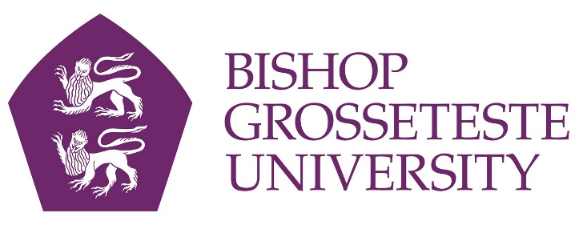
News release

3rd November 2016

BGU Chosen for Study into Benefits of University Education

A national pilot study has been launched to track improvements in knowledge, skills, work-readiness and personal development made by university students - and Bishop Grosseteste University in Lincoln is one of only ten chosen to take part.

BGU has been selected by HEFCE (the Higher Education Funding Council for England) to take part in a study into students' Learning Gain which is being launched this week.

As part of the National Mixed Methodology Learning Gain Project (NMMLGP) BGU students will be asked to analyse their learning to better understand the benefits of studying at university.

The NMMLGP aims to track different aspects of the learning gain experienced by higher education students through their three-year programmes of study. It is part of HEFCE's wider work with the higher education sector to develop better ways of capturing excellent educational outcomes and will be a feature of the new Teaching Excellence Framework (TEF).

HEFCE will work with ten higher education institutions, including BGU, to collect data from students at four points across three years of undergraduate study through an electronically administered assessment programme.

This will include a test of students’ critical thinking and problem-solving skills, as well as questions about their attitudes to different elements of their studies and engagement with their course.
“This is a fantastic opportunity for BGU to be part of a national initiative that will track students’ progress over three years and which builds on our already excellent work in supporting students learning,” said Professor Jayne Mitchell, Deputy Vice Chancellor of BGU.

“We are extremely fortunate to have been selected to participate in the project. There are many potential benefits to students and the university from developing a better understanding of how to students learn, to enable them to achieve their full potential.”

BGU’s participation in the project will be co-ordinated through the Centre for Enhancement of Learning and Teaching. Dr Claire Thomson, Head of the Centre for Enhancement in Learning and Teaching at BGU, said: “We are delighted to have the opportunity to support and promote this exciting initiative and look forward to using the results to make further improvements to BGU students’ whole learning experience.”

Luke South, Vice President for Education at Bishop Grosseteste Students’ Union, added: “We are supporting the university in this project as we feel it is a great opportunity for students to reflect on their learning and the ways in which they can progress.”

HEFCE’s announcement about the project can be found here: http://www.hefce.ac.uk/news/newsarchive/2016/Name,110708,en.html

Notes to editors:

- Bishop Grosseteste University was established in January 1862 and celebrated its 150th anniversary in 2012.
- It is an independent higher education institution based in Lincoln which awards its own degrees at foundation, undergraduate and postgraduate level.
- It changed its name from Bishop Grosseteste University College to Bishop Grosseteste University in November 2012.
- BGU has over 2,300 students, including undergraduate, postgraduate and research, with over 280 students at collaborative partners across Lincolnshire.
- In 2015 BGU was the second highest ranked university in the UK for employability with almost 99% of leavers in work or study six months after graduating (2013/14 DLHE).
- To learn more about Bishop Grosseteste University visit www.bishopg.ac.uk
- The Teaching Excellence Framework (TEF) was introduced by the Government to recognise and reward excellent learning and teaching.
- Higher education providers who meet the eligibility criteria are invited to apply for a Teaching Excellence Framework rating and will be evaluated on the quality of teaching and the outcomes they achieve for their students.

For media information please contact:
Jez Ashberry
Shooting Star
01522 528540
07780 735071
jez@weareshootingstar.co.uk
[BGU199learninggain]

