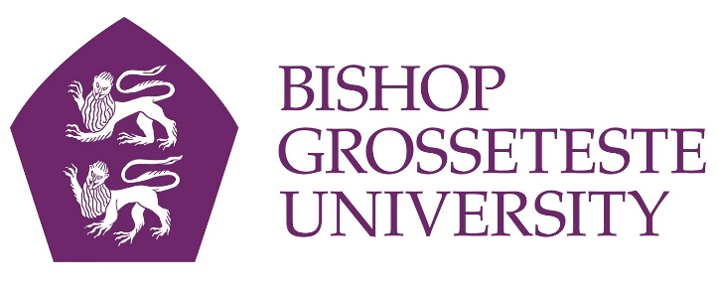

News release

15th November 2016

Lecturers to Stand Up for Laughs at BGU

Lecturers at Bishop Grosseteste University will be swapping lecterns for laughter again when Bright Club returns next week.

A group of academics will become stand-up comics for the night as part of a nationwide project to communicate research in a more engaging way.

BGU held its first Bright Club night of academic stand-up in May this year and the event was such a success that they’ll be doing an encore on Wednesday 23rd November.

The would-be comics, including doctoral student Karen Dainty and Elinor Vettraino, Academic Co-ordinator for Business & Enterprise, are being coached by Simon Bligh, a professional comedian who will also be compering the event.

“The life of an academic researcher can be a lonely one, so this is a great way for colleagues to get together in a social setting and talk about their work in a fun and engaging way,” said Elinor, who is organising the event as well as hoping to raise a laugh with her own routine.

“They may be used to describing their research at conferences, but Bright Club is a completely different experience and a chance for them to ruse their research as a way to raise a few laughs.

“It is nerve-racking, but a the end of the day the audience is on our side and everyone has a great time. The experience can really help lecturers to come up with new ways to communicate effectively with their students.”

Tickets for the event cost £5 on the door (£3 for students) at Curiositea and are open to members of the public as well as to BGU staff and students. Doors open at 7.30pm and the event starts at 8pm on Wednesday 23rd November.

Universities involved in Bright Club include Cambridge, Oxford, Leicester, Loughborough, Manchester, St Andrews, Belfast, Bristol, Dublin, Dundee, Edinburgh, Glasgow and Surrey (Guildford).

To find out more about Bright Club visit http://brightclub.org/

Notes to Editors

- Bishop Grosseteste University was established in January 1862 and celebrated its 150th anniversary in 2012.
- It is an independent higher education institution based in Lincoln which awards its own degrees at foundation, undergraduate and postgraduate level.
- It changed its name from Bishop Grosseteste University College to Bishop Grosseteste University in November 2012.
- BGU has over 2,300 students, including undergraduate, postgraduate and research, with over 280 students at collaborative partners across Lincolnshire.
- In 2015 BGU was the second highest ranked university in the UK for employability with almost 99% of leavers in work or study six months after graduating (2013/14 DLHE).
- To learn more about Bishop Grosseteste University visit www.bishopg.ac.uk
- Bright Club began life at UCL – more information can be found at http://www.brightclub.org/

For media information please contact:
Jez Ashberry
Shooting Star
01522 528540
07780 735071
jez@weareshootingstar.co.uk
[BGU202brightclub]

