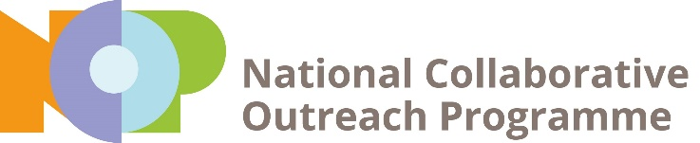 | 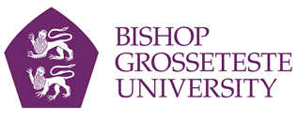

News release

24th January 2017

Bishop Grosseteste University Leading Scheme to Improve Access to Higher Education

Bishop Grosseteste University in Lincoln is attending the launch of the National Collaborative Outreach Programme in Birmingham today (Tuesday).

Deputy Vice Chancellor Professor Jayne Mitchell and Project Manager Naomi Prendergast are at the launch of the scheme, which aims to encourage more young people from disadvantaged backgrounds to go to university.

BGU is leading NCOP in Lincolnshire and is at the head of a consortium of Lincolnshire universities, colleges and schools, called LiNCHigher, which successfully bid for £2.5 million to roll out the programme across over the next four years.

LiNCHigher will involve young people from across the county and deliver tried and tested approaches to raising aspirations and progression to HE as well as develop innovative ways to meet the specific challenges the county faces.

These activities will build upon and provide a boost to existing outreach work taking place in schools and communities across England.

A large-scale evaluation programme will measure the impact of the programme from the start, and the aim will be to build a powerful evidence base to ensure that investment is concentrated in activity that is shown to be the most effective.

“We’re delighted that our bid to lead this exciting project has been successful,” said Professor Jayne Mitchell, Deputy Vice Chancellor at Bishop Grosseteste University.

“We will be working together with colleges, universities and our network of schools to meet the education and skills needs in Lincolnshire.

“The LiNCHigher project is designed to raise aspirations and support Lincolnshire’s young people to achieve their education goals. It will make a real difference to young people’s lives, and by investing in higher education we will help to improve the social and economic prosperity of the whole county.”

In leading this programme BGU will build on its already successful track record and reputation for providing opportunities for students from under-represented groups to study and succeed in higher education.

Over 84% of BGU students identify with one or more characteristic of those under-represented in HE; disabled, BME, mature, low-income background, low-participation neighbourhood and/or male.

BGU students are well supported to achieve their qualifications and gain jobs. According to the latest Destinations of Leavers from Higher Education (DLHE) survey, published by HESA (Higher Education Statistics Agency), 98.6% per cent of students who leave BGU with an undergraduate degree find work or are continuing to study six months following graduation. This places BGU as the highest ranked public university in England for student employability.

The LiNCHigher project will run from 2016/17 to 2019/20.

BGU’s consortium partners are the Bishop Burton College, Boston College, the College of West Anglia, Grantham College, Grimsby Institute, Lincoln College, Lincoln University Technical College, New College Stamford and University of Lincoln.

Notes to editors:

- Bishop Grosseteste University was established in January 1862 and celebrated its 150th anniversary in 2012.
- It is an independent higher education institution based in Lincoln which awards its own degrees at foundation, undergraduate and postgraduate level.
- It changed its name from Bishop Grosseteste University College to Bishop Grosseteste University in November 2012.
- BGU has over 2,300 students, including undergraduate, postgraduate and research, with over 280 students at collaborative partners across Lincolnshire.
- To learn more about Bishop Grosseteste University visit www.bishopg.ac.uk
- To find out more about NCOP visit http://www.hefce.ac.uk/sas/ncop/.

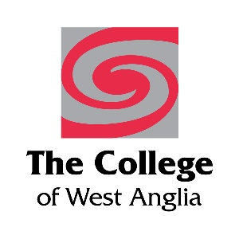

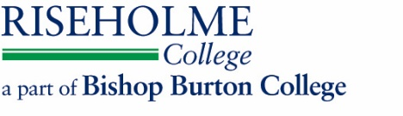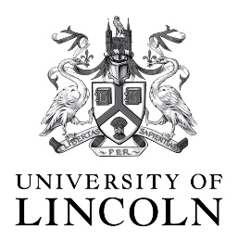

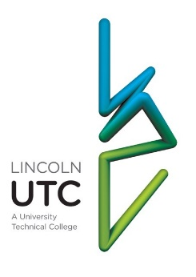

For media information please contact:
Jez Ashberry
Shooting Star
01522 528540
07780 735071
jez@weareshootingstar.co.uk
[BGU208NCOPlaunch]

