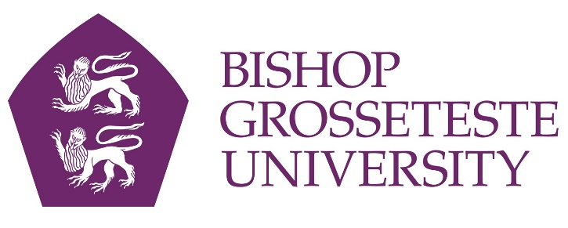
News release

14th July 2017

Mother and Daughter to Graduate Together at BGU

A mother and her daughter will graduate together from Bishop Grosseteste University in Lincoln on Wednesday 19th July.

Sharon Tory (47) will be graduating with a Foundation Degree (FdA) in Professional Studies (Early Childhood) while her daughter Megan Tory (21) will be graduating with a BA (Hons) degree in Early Childhood Studies.

The mother and daughter duo from Boston came to study together at BGU after attending an open day intended for Megan, who was looking for an early years degree programme.

But Sharon had always wanted to be a teacher, and when she heard about the FdA Professional Studies course she knew it would be ideal for her.

“I already work with young children at a pre-school and I didn’t think it would be possible to study for a degree alongside my job, but when I found out that the FdA course would allow me to do both I knew I had to consider it,” said Sharon.

Megan started the three-year BA (Hons) Early Childhood Studies course in September 2014 and was the first in her family to go to university. “I never wanted to be too far away from home so BGU was the perfect choice for me living in Boston.” said Megan.

After debating whether to go ahead or not, Sharon began the two-year FdA degree a year later in September 2015.

Sharon said: “At the start, it was a bit of a challenge getting used to working and doing a degree at the same time, but overall the whole experience has been so rewarding.

“I never thought I would be able to do it, so it’s definitely going to be a proud moment graduating alongside my daughter.”

Sharon will continue her studies via the progression route onto the BA (Hons) Professional Studies course this September at BGU, and follow on with a QTS course to become a teacher.

Sharon Tory will graduate at 2.30pm and Megan Tory will graduate at 10.15am at Lincoln Cathedral on Wednesday 19th July 2017.

If you would like to interview or photograph Sharon and Megan Tory please contact Shooting Star on 01522 528540 or email jez@weareshootingstar.co.uk.

Notes to Editors
- Bishop Grosseteste University was established in January 1862 and celebrated its 150th anniversary in 2012.
- It is an independent higher education institution based in Lincoln which awards its own degrees at foundation, undergraduate and postgraduate level.
- It changed its name from Bishop Grosseteste University College to Bishop Grosseteste University in November 2012.
- BGU has over 2,300 students, including undergraduate, postgraduate and research, with over 280 students at collaborative partners across Lincolnshire.
- In 2015 BGU was the second highest ranked university in the UK for employability with almost 99% of leavers in work or study six months after graduating (2013/14 DLHE).
- This summer’s graduation BGU ceremonies will take place at Lincoln Cathedral on Wednesday 19th and Thursday 20th July 2017.
- To learn more about Bishop Grosseteste University visit www.bishopg.ac.uk

For media information please contact:
Jez Ashberry
Shooting Star
01522 528540
07780 735071
jez@weareshootingstar.co.uk
[BGU219gradmotherdaughter]

