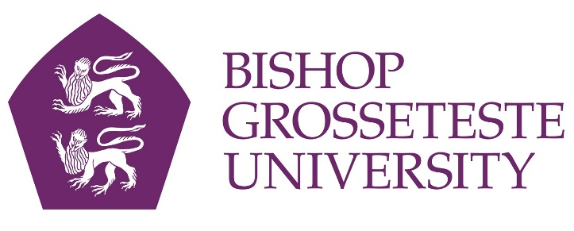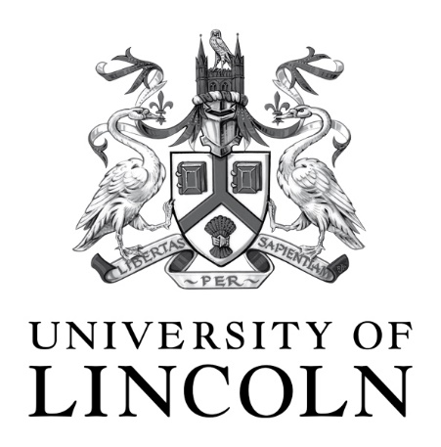

News release

21st June 2017

Double Gold for Lincolnshire’s Two Universities in
National Teaching Quality Assessment

Strictly embargoed until 00:01 on Thursday 22nd June 2017

Lincolnshire's two universities have both been given the highest rating possible in a new national assessment of the quality of teaching, learning and student achievement in UK higher education.

Both Bishop Grosseteste University and the University of Lincoln were awarded a Gold rating by a panel of independent experts in the Teaching Excellence Framework (TEF).

The TEF was introduced by the Government to build a new picture of excellence in teaching and learning in UK’s world-class higher education sector. Local business leaders have today welcomed the Gold awards for the county’s two universities.

Ursula Lidbetter MBE, Chair of the Greater Lincolnshire Local Enterprise Partnership, stated: “To have both universities in the county rated as gold is truly outstanding and an indication of the quality of experience students can expect when coming to study in Lincolnshire.

“I'd like to commend both institutions for their dedication to ensuring that students receive a first class education and the contribution each institution makes to improving the life chances of our young people and the economic prosperity of the county.”

Lincolnshire's two universities are among only 26% of higher education providers from across the whole of the UK to be awarded a Gold rating.

The TEF Panel judged that both Bishop Grosseteste University and the University of Lincoln deliver consistently outstanding teaching, learning and outcomes for students. In their written summaries, they said the University of Lincoln showed “a comprehensive and embedded approach to student engagement that provides opportunities for students and staff to work closely together” and commended on the “outstanding physical and digital resources which pervade all aspects of student experience, including state-of-the-art teaching spaces”.

The Panel praised BGU as a university where "employability and enterprise skills are embedded throughout the student experience, enabling students to acquire knowledge, skills and understanding that are most highly valued by employers.”

Fantastic news for the city

Professor Mary Stuart, Vice Chancellor at the University of Lincoln, said: "We are delighted to have been awarded Gold in the Teaching Excellence Framework (TEF). We already pride ourselves on the education, experiences and opportunities we offer our students. Our TEF Gold award is further evidence of our exciting teaching, great support for students and excellent employment outcomes. It is testament to the talents and endeavours not just of our teaching staff but of everyone who makes up our academic community, including our students who so enthusiastically embrace the opportunities and challenges presented to them.”

She added: "It is fantastic news for Lincoln that both the city’s universities have been awarded Gold in the TEF. It shows that people across the region are benefiting from the life-changing opportunities that higher education can bring and also puts Lincoln firmly on the map as a top destination for students from across the UK and overseas.”

The Vice Chancellor of Bishop Grosseteste University, the Reverend Canon Professor Peter Neil, commenting on the TEF outcome, said: “To be judged to be in the top 26% of higher education providers across the whole country is confirmation of the quality of the education our students receive at BGU. It is also evidence that students who come to BGU are very likely to complete their studies successfully and to gain employment in the shortest possible time following graduation. We’re also pleased to see our investment in new teaching resources recognised– as evidenced by our fantastic new building that can be seen from the roundabout.

“This is excellent news for students coming to Lincoln that both universities are offering a gold standard teaching and learning experience. The city is privileged to have such high quality institutions to offer. I have always been confident that we offer a gold standard experience to our students. However to receive this external judgment at national level by the panel of experts is very pleasing indeed.”

The TEF aims to help better inform students' choices about what and where to study, raise the esteem of teaching, recognise and reward excellent teaching and better meet the needs of employers, business, industry and the professions. Outcomes were published today (22nd June 2017) for almost 300 education providers by the Higher Education Funding Council for England.

Notes to editors

Bishop Grosseteste University

      - Bishop Grosseteste University was established in January 1862 and celebrated its 150th anniversary in 2012.
      - BGU is a top three university for student employability with over 97% of leavers in work or study six months after graduating (2014/15 DLHE – read more here).
      - BGU is the 2nd highest ranked public university in England for student satisfaction (National Student Survey 2016 – read more here).
      - BGU has over 2,300 students, including undergraduate, postgraduate and research, with over 280 students at collaborative partners across Lincolnshire.
      - To learn more about Bishop Grosseteste University visit www.bishopg.ac.uk

University of Lincoln

- The University of Lincoln is a top 50 UK university (The Guardian University Guide 2018; Complete University Guide 2018).
- It has some of the most satisfied students in the UK, placed in the top 10 for student satisfaction in the National Student Survey 2016 and rated in the top 10 for student experience and teaching quality in The Times and Sunday Times Good University Guide 2017.
- It is known for its pioneering approach to working with employers, winning a Lord Stafford Award and a Times Higher Education Award.
- Graduate prospects are strong with 95% of Lincoln’s most recent graduates in work or further study six months after finishing their course and almost three-quarters in graduate level roles.
- In the Research Excellence Framework 2014, more than half of submitted research was judged to be internationally excellent or world-leading.
- For more information visit www.lincoln.ac.uk

Teaching Excellence Framework

- The Teaching Excellence Framework – the first scheme of its kind – recognises excellent teaching and learning across the UK’s world-class higher education sector.
- In order to be considered for a TEF rating, higher education providers have to meet demanding national quality requirements. The TEF measures excellence above and beyond this.
- The full list of ratings for each higher education provider is published at www.hefce.ac.uk/lt/tef/.
- The TEF awards are decided by an independent panel of experts, including academics, students and employer representatives.
- The TEF measures teaching excellence in three key areas: teaching quality, learning environment and student outcomes.
- Participation in the TEF is voluntary. Across the UK, 295 higher education providers (universities, colleges and alternative providers) participated. Of these, 231 providers applied for a TEF assessment (resulting in a gold, silver or bronze award) while the remaining 64 providers opted-in for a provisional award.
- Of the 295 participating providers, 134 were higher education institutions (HEIs), 106 were further education colleges (FECs) and 55 providers were alternative providers (APs).

For media information please contact:

Jez Ashberry (BGU)
Shooting Star
01522 528540
07780 735071
jez@weareshootingstar.co.uk

or
Ian Richards
University of Lincoln Press Office
irichards@lincoln.ac.uk
01522 886042 / 01522 886244
[BGU225TEF]

