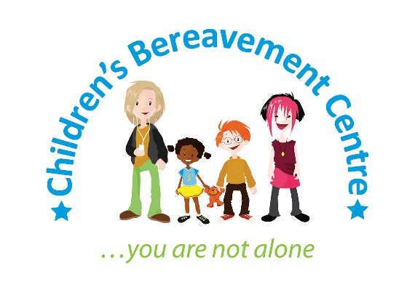

News release

7th March 2017

The Children’s Bereavement Centre Needs You!

Looking to do some charity fundraising in 2017? Then the Children’s Bereavement Centre wants to hear from you.

The charity, which offers free support to children and their families when they have suffered the loss of someone close to them, is urging people to consider fundraising for the cause throughout 2017 to help develop its services in Bassetlaw, Nottinghamshire.

Outreach Co-ordinator Ruth Farrow has been working closely with local schools, GPs and health care professionals to help raise awareness of the charity since it expanded into the area in 2016.

The charity currently operates from rooms in The Well and New Life Church in Retford and Gateford Children’s Centre in Worksop and meets with clients on a weekly basis.

Ruth said: “Now that our services are established in Bassetlaw, we are concentrating on bringing workshops to the area that will support groups of children and families who have been bereaved which will enable us to help even more people closer to their homes.

“To do this, we need to raise as much money as possible and we’re grateful for any support the public can give.”

Caz Frogatt, Corporate and Community Engagement Coordinator, added: “If you’re looking to take on a challenge for charity in 2017, as an individual or an organisation or school, then please get in touch. We’d love to meet you to discuss the exciting ways we could work together.”

The Children’s Bereavement Centre supports children and families from Nottinghamshire and parts of Lincolnshire who have experienced the death, terminal illness, divorce or separation of someone close to them.

Before the charity began to operate outreach centres in Bassetlaw, service users were having to make the 40-mile or more round-trip to visit the charity at its centre in Newark.

To discuss fundraising for the charity, please call 01636 551739 or email info@childrensbereavementcentre.co.uk.

Alternatively, you can find out more about fundraising opportunities and download a sponsorship form by visiting: www.childrensbereavementcentre.co.uk/fundraising/

For more information about the Children’s Bereavement Centre visit: www.childrensbereavementcentre.co.uk
Ends
Notes to Editors:
- The Children’s Bereavement Centre is a registered charity that provides pre-bereavement, bereavement and loss support to hundreds of children and young people aged three to 18. All the children and young people who receive support have experienced trauma due to terminal illness, death or the divorce or separation.
- The charity’s services are available to anyone living in Nottinghamshire and parts of Lincolnshire.
- Between 2015 and 2016 the Children’s Bereavement Centre supported more than 600 children, young people and their families.
- The charity aims to ensure that children, young people and their families receive timely support so they can remain healthy and in education and go on to reach their full potential.
- Its free support services include one-to-one children’s support, play therapy, filial therapy and peer groups as well as counselling and support for parents and carers.
- Full address: Children’s Bereavement Centre, 3 Kings Road, Newark, Notts NG24 1EW
- For more information visit: www.childrensbereavementcentre.co.uk

For media information, please contact:
Zoe Lamb
zoe@weareshootingstar.co.uk
Shooting Star
01522 528540
[CBC02BassetlawSupport]

