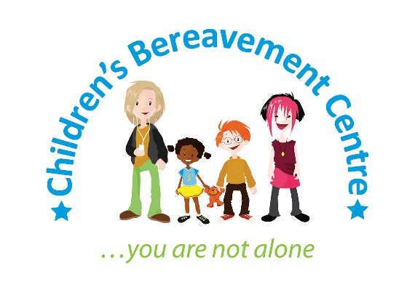
News release

11th September 2017

Children’s Charity Holds 10th Annual Bereavement Camp

A group of young people dealing with the loss of someone close to them enjoyed a well deserved break at the Children’s Bereavement Centre’s residential bereavement camp.

On Friday 28th July 21 children and young people aged between six and 18 arrived at the White Hall Outdoor Education Centre in Buxton and spent two days engaging in practical, creative and therapeutic activities to help build confidence and self-esteem and encourage teamwork.

Since it was established in 2007, the camp has been led by Paula Drummond, Clinical Team Lead at the Children’s Bereavement Centre, together with a dedicated team of staff and volunteers.

This year Paula was supported by two fellow staff members, 15 volunteers and two practical helpers – including Ollie, who benefitted from the very first camp and returned to transport staff and equipment to the venue when setting up.

He said: “I was keen to help out in any way I could, as this camp will always hold a special place in my heart.

“It’s fantastic to see that, ten years on, it’s still a significant event in the calendar and that local children and young people are continuing to benefit from expert support – and have a bit of fun along the way too.”

The camp and the activities which took place were based on the model used by Winston’s Wish, the UK’s first childhood bereavement charity, and Julia Stokes’ guide for practitioners ‘Then, Now and Always’.

Parents and carers were invited to attend the closing ceremony at the end of the two-day event, which included a feedback session to help shape the programme.

Paula said: “Camp activities provide an opportunity for the children to meet others in a similar situation, share their stories and express a range of feelings, and prepare for challenges ahead.

“All of this is important for helping individuals to understand and cope with their grief, while enjoying some much-needed respite.

“We are so grateful to St James’s Place Foundation and Paul Burrows from Atlas Wealth Management, who very kindly donated the funding for this year’s camp.

“To talk to us about funding next year’s camp or about how you can get involved in some of our other annual activities, such as our family fun day or candlelight service, please get in touch.”

You can contact the Children’s Bereavement Centre by calling 01636 551739 or emailing info@childrensbereavementcentre.co.uk

Ends
Notes to Editors:
- The Children’s Bereavement Centre is a registered charity that provides pre-bereavement, bereavement and loss support to hundreds of children and young people aged three to 18. All the children and young people who receive support have experienced trauma due to terminal illness, death or the divorce or separation.
- The charity’s services are available to anyone living in Nottinghamshire and parts of Lincolnshire.
- Between 2015 and 2016 the Children’s Bereavement Centre supported more than 600 children, young people and their families.
- The charity aims to ensure that children, young people and their families receive timely support so they can remain healthy and in education and go on to reach their full potential.
- Its free support services include one-to-one children’s support, play therapy, filial therapy and peer groups as well as counselling and support for parents and carers.
- Full address: Children’s Bereavement Centre, 3 Kings Road, Newark, Notts NG24 1EW
- For more information visit: www.childrensbereavementcentre.co.uk

For media information, please contact:
Kerri Saxby
kerri@weareshootingstar.co.uk
Shooting Star
01522 528540
[CBC05BereavementCamp]

