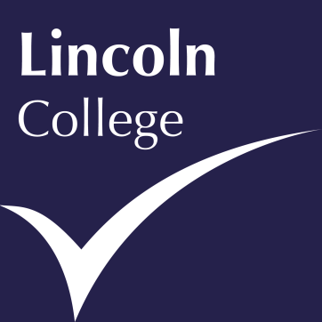
News Release

13th August 2015

Lincoln College Group Maintains its Fantastic A-Level Performance
After another year of hard work and dedication the percentage of students at Lincoln and Newark Colleges achieving pass grades in their final year is 98 per cent.
This equalled last year’s pass rate and 30 per cent of students achieved the very highest grades of A* to B.
On top of this success there was a 100 per cent pass rate in English, with 18 per cent of those getting A* in English Literature, and 51 per cent of students getting A* to B grades in maths.
Performance was even stronger at the Group’s Newark Academy, with a 100 per cent pass rate for the third year running.
The Lincoln College Group Managing Director of Education and Training Delivery, Mark Locking, said: “We are delighted with these results – they represent a huge amount of effort on the part of our students and teaching staff. I’d like to personally congratulate all of our learners - they have done themselves, their families and their tutors proud.”
Newark College Director Martin Booth said: “These are really positive results, which are reflective of the dedication of our students and the professionalism of our teaching staff. We wish all of our learners the very best of luck in their further studies and future careers.”
Newark Academy Principal Karine Jasper said: “The fact that we are maintaining great pass rates at Newark Academy is testament to the efforts of our students and the tremendous teaching from our tutors. We are so proud of our learners and we wish them all the best – this is a great day for them.”
The Lincoln College Group, at Lincoln, Gainsborough and Newark, is open for business, with spaces on higher education, full and part-time vocational courses and apprenticeships still available.
Call our Clearing Hotline Number on: 01522 876398
Get free impartial careers advice on: 030 030 32435
Find the course for you - visit: www.lincolncollege.ac.uk
If you didn’t get the results you wanted, stay calm, take stock, then act; don’t brood for days or you’ll miss your chance of getting on a course. To discuss re-sit options get in touch with your school or college soon as possible.
If you’re in Lincoln, Newark or Gainsborough you can pop into our colleges and get free impartial advice from a careers adviser, who can help you start to sort the problem out there and then, or you can call our hotline number or visit our website.
For university applicants, if you haven’t got your first choice or insurance choice, you can still apply through UCAS Clearing to other universities, along with Lincoln College. If you go to the UCAS homepage you will see ‘Clearing 2015’, here you will be able to find all the organisations that have vacancies.
At Lincoln College we offer a range of higher education courses in a range of subjects from acupuncture to business and we still have spaces available, so please get in touch. More than 90 per cent of our higher education students get a job or go on to further study.
If you’ve decided higher education isn’t for you and you want start your career now, you can earn while you learn and train in industry environments on our apprenticeships and vocational courses. We work really closely with local firms and make our courses fit what they need – that means you’ve got a much better chance of getting a job.

Ends

Notes to Editors

About The Lincoln College Group:
- Founded upon a concept of ‘synergy’, The Lincoln College Group comprises a number of like-minded organisations with a shared purpose of providing exceptional education, training and related services to their students.
- Currently providing secondary, further and higher education, the Group includes Lincoln College (with its campuses in Lincoln, Newark and Gainsborough and operations in China) and two secondary school academies: The Newark Academy and The Gainsborough Academy. It also encompasses Deans Sport and Leisure, a commercial sports centre based in Lincoln City Centre.
- Lincoln College International, a project to develop and run three Colleges in the Kingdom of Saudi Arabia is the latest addition to the Group.
- The Lincoln College Group is also the lead sponsor of the Lincoln UTC which opened in September 2014.

For further information about this release please contact:

Kate Strawson
Director, Shooting Star
Kate@weareshootingstar.co.uk
01522 528540
07733 230293
@KateStrawson
www.weareshootingstar.co.uk

