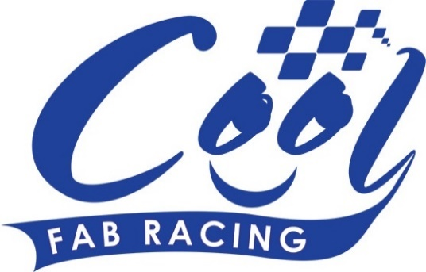
News Release

31st March 2016

Swedish Superbike Star Backs Cool FAB Racing at Llandow

The Easter weekend saw the 2016 Cool FAB Racing British Minibikes Championship get off to an exciting start at Llandow in Wales.

Sponsor Cool Milk brought a new level of professionalism to the championship in the form of the Quattro Plant Cool Kawasaki team and Swedish superbike star Filip Backlund.

Pete Extance, Team Principal, said: “We were delighted to be invited by Cool Milk to go along to the new Cool Fab Racing series. It was a fantastic opportunity for the up-and-coming riders of the future to meet Filip and experience the team’s hospitality. We thoroughly enjoyed round one at Llandow and look forward to seeing the riders again at Whilton Mill for round four.”

Filip added: “I am extremely pleased to be an ambassador of the Cool Fab Racing series and look forward to working with young riders and their parents to help them develop their skills on and off track.

“This was my first experience of Cool FAB Racing and I was extremely impressed with the set-up and the talent on display. I was able to work alongside the young riders and offer support on various elements of their racing such as their riding technique and setting up the bike.

“It was a great weekend and I am looking forward to being a positive role model for Cool Milk and Quattro Plant Cool Kawasaki as they develop the next generation of British Superbike riders.”

Moto2 GP rider Danny Kent, who started his racing career competing in the FAB Racing MiniGP Series, was also trackside supporting his brother Kieran.

Despite the challenging weather conditions, it was a fantastic start to the 2016 season with the 2015 MiniGP 70 champion, 12-year-old Elliot Pinson from Swindon, overcoming a fall in the third qualifying race to be named overall winner in his class.

Overall winner in the MiniGP 50 was 10-year-old Calum Beach from Abergele in Conwy while Harvey Claridge and Scott Ogden came second and third respectively.

Aleksander Merchant, who finished 10th in the championship last year, took top spot overall in the AC40 Rookies while Bailey Stuart-Campbell, who finished 16th last year, came first in the AC40 Pro class.

In the PitBike Open, BSB riders Fraser Rogers, Charlie Nesbitt, Max Cook, Cameron Horsman and TJ Toms fought a hard battle but Max, who finished second in the championship last year, came out on top.

In the PitBike 140, Henry Mostran finished first and in the MotoTeam category SAB Racing’s Steve Ball claimed top spot overall.

In the MiniF1 Sidecars class Paul Qualters and Big Girl Racing started the 2016 season with a win overall and first position in the Junior LC40 class was won by last year’s MiniGP 50 champion Joshua Whatley.

Managing Director of Cool Motor Racing, the company delivering Cool Milk’s 10-year sponsorship deal with FAB Racing, Crispin Vitoria said it was an exciting opening round: “This weekend has shown that we’ve got a lot of talented riders who are hopefully going to rise through the ranks and we’re very excited to see how the 2016 season will unfold.

“As the MD of Cool Motor Racing my aim is to make sure that in ten years’ time we have more British riders at the top of British motorsport and we’re starting here in Llandow with the young riders who’ve taken part in the first round of the championship.

“We have some really ambitious plans for this championship. There’s a lot of things we want to do and already we have made quite a few changes which hopefully the riders, their families and the spectators will really enjoy.

“Having the Quattro Plant Cool Kawasaki team here today including BSB Superbike rider Filip Backlund also added to the experience, especially for the youngsters who were able to get a taste of what it’s like to be at the top of the sport.”

Organiser of the Cool Fab Racing British Championship Roger Keys added: “I was very impressed with the way the young riders coped with the rain and the high winds but fortunately Sunday was much better weather and we were very pleased with the way it went.

“It’s fantastic to have Cool Milk on board as a partner. Hopefully it will give us a much higher profile to enable us to attract more riders and produce even more future British champions.”

Entries are now being welcomed for Round 2 of the 2016 Cool FAB Racing British Championship at Red Lodge in Bury Saint Edmunds. Numbers are limited so riders are advised to get their entries in early to avoid disappointment. For further information, please visit www.coolfabracing.com

Ends

