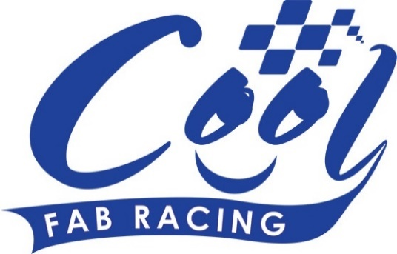
News Release

18th April 2016

Superbike Stars Enjoy a Cool FAB Weekend

It was an all-star line up for Round 2 of the Cool FAB Racing British Minibikes Championship in Bury St Edmunds at the weekend.

As well as an appearance by British superbike rider Luke Mossey, who is currently sixth in the championship following the opening round at Silverstone, 2015 British F1 sidecar champions Ricky Stevens and Ryan Charlwood were also trackside to give the youngsters the benefit of their experience.

Over 120 riders, some as young as six years old, took part in the three-day event which got under way on Friday (15th April) with practice sessions followed by two full days of racing on Saturday and Sunday.

Luke, who is from Royston in Cambridgeshire, said: “Being in the paddock at Red Lodge brought back a lot of memories of competing in the championships in 2004 when I was a kid.

“I thoroughly enjoyed the weekend and it was great to see the young riders and their enthusiasm for the sport. I was very impressed with the standard of racing and it was a privilege to meet the riders and their parents and present them with their trophies afterwards.”

The AC40 Rookies category was particularly hotly contested with Ben Smith from Oldham coming first overall, followed by Cameron Soole and Alek Sander-Merchant who were only one point apart.

The AC40 Pro was another good race with Casey O’Gorman, from Erith in Kent, coming out on top followed by Owen Mellor and Bailey Stuart-Campbell. In the Junior LC40 Josh Whatley from Alfreton in Derby finished in the top spot. This time Casey O’Gorman came second and Lois Rendall was third.

In the MiniGP 50 Harvey Claridge from Steyning in West Sussex was first overall followed by Scott Ogden and Casey O’Gorman, this time in third. And in the MiniGP 70 overall winner in Round 1, Elliot Pinson, lost out to Josh Whatley by two points after falling off in race three. Franco Bourne came third.

Organiser of the Cool Fab Racing British Championship Roger Keys said Round 2 was a real test of skill.

“We had four seasons in one weekend weather-wise,” explained Roger. “On the Saturday it was cold and wet and on the Sunday it was dry and sunny so the riders had to cope with very changeable racing conditions and I thought they all stepped up to the challenge remarkably well.”

Crispin Vitoria, Managing Director of Cool Motor Racing, the company delivering Cool Milk’s 10-year sponsorship deal with FAB Racing, said: “It was another entertaining weekend with some really competitive racing, particularly in the AC40 Rookies which was neck and neck in every race.

“We were particularly pleased to welcome Luke and Ricky and Ryan to the track and would like to thank them for being such enthusiastic ambassadors for the sport.”

Downforce Radio provided live coverage of all of the action. To listen again visit www.downforce-radio.co.uk

For more information or to enter Round 3 of the 2016 Cool FAB Racing British Championship at Rowrah in Cumbria www.coolfabracing.com

Ends

For further information about this news release please contact:
Kate Strawson
Shooting Star
01522 528540
07733 230293
kate@weareshootingstar.co.uk
www.weareshootingstar.co.uk
@KateStrawson

