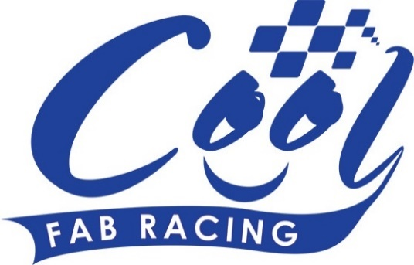
News Release

23rd May 2016

Ricky & Ryan Head to Rowrah for Round 3

Spectators at the next round of the Cool FAB Racing British Minibikes Championship in Rowrah (27th to 29th May) can look forward to an exciting weekend of racing.

Race goers will also have the chance to meet reigning British F1 sidecar champions Ricky Stevens and Ryan Charlwood, who are fresh from action at Brands Hatch, where they enjoyed a close-fought battle with world champions Tim Reeves and Greg Cluze but in the end had to settle for second place.

Ryan said he’s looking forward to seeing the riders in action: “The standard of racing is incredibly high and these kids have so much talent at such a young age. We’re really enjoying our new roles as Cool FAB Racing ambassadors and watching the youngsters compete. Hopefully with a lot of hard work and dedication they can go on to become the British champions of the future.”

In Round 2 of the Cool FAB Racing championship at Red Lodge in April, Elliot Pinson (12) from Swindon won the first two races in the MiniGP 70 but came fourth in race 3 which cost him in the overall results. Joshua Whatley (10) from Alfreton in Derbyshire, finished first overall, two points ahead of Elliot. However, Elliot currently sits eight points in front of Joshua in the championship with 123 points.

Also promising to deliver plenty of thrills is the MiniGP 50 class which was dominated by Harvey Claridge (10) from Steyning, West Sussex, at Red Lodge in Round 2. The conditions were very favourable for Harvey, who is very good in the wet, but that could all change at Rowrah.

There is also a three-way battle for the top spot in the AC40 Rookies between Ben Smith (7), Aleksander Merchant (6) and Cameron Soole (7) which looks set to continue all season.

Another favourite with Cool FAB Racing fans is the Pitbike Open. BSB riders Charlie Nesbitt and TJ Toms are almost neck and neck in the championship with just four points separating them, and Max Cook is hot on their heels in third place with 104 points.

Downforce Radio and will be providing live commentary on the day. Listen online at http://downforce-radio.co.uk/

There is still time to enter Round 3 of the 2016 Cool FAB Racing British Championship at Rowrah in Cumbria. Numbers are limited so riders are advised to get their entries in early to avoid disappointment. Visit www.coolfabracing.com for more information.

Ends

For further information about this news release please contact:
Kate Strawson
Shooting Star
01522 528540
07733 230293
kate@weareshootingstar.co.uk
www.weareshootingstar.co.uk
@KateStrawson
[Cool04Rowrah]

