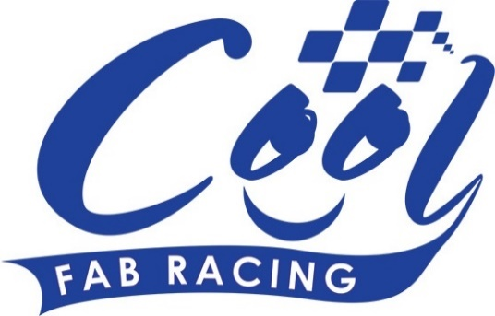
News Release

6th June 2016

Exciting Line Up Ahead for Cool FAB Championship in Llandow

Superbike rider Filip Backlund, Supersport rider Andy Reid and F1 sidecar team Ricky Stevens and Ryan Charlwood are all headed to the Cool FAB Racing British Minibikes Championship in Llandow, Wales, this weekend.

The three-day event will kick off this Friday 10th June with practice sessions followed by two full days of racing on Saturday and Sunday.

The different categories are hotly contested across the board so this round promises some exciting racing action for race goers.

Crispin Vitoria, Managing Director of Cool Motor Racing, the company delivering Cool Milk’s 10-year sponsorship deal with FAB Racing, said: “We’re expecting to see even more great racing this weekend as we approach the half way mark in the championship. The racing is becoming even more competitive as the riders battle it out for every valuable point and position on the grid.

“In the MiniGP70, Franco Bourne and Blake Ansell are tied on 152 points in the Championship, while in the AC40 Pro Sandy Horne and Adon Davie are neck and neck with only three points separating them overall!

“On top of this, we are joined by the 2015 British F1 sidecar champions Ricky Stevens and Ryan Charlwood as well as British Superbike star Filip Backlund and British SuperSport rider Andy Reid. All of these riders are fantastic ambassadors for the sport and we’re thrilled to be hosting them.”

Andy Reid, who is currently leading the SuperSport championship, will be attending the Cool FAB Racing British Minibikes Championship for the first time and will be advising the young riders trackside alongside his Quattro Plant Cool Kawasaki team mates.

Andy said: “I am really looking forward to my first experience of the Cool FAB Racing series. It’s going to be fun watching all the young riders race as I have heard great things about the talent coming through the series. It will be good to chat with the riders and their parents and hopefully I will be able to pass on some tips to help them develop their skills.”

At the last round in Rowrah, Cool Motor Racing announced a partnership with seven British Superbike teams who will support their own junior teams in the Championship, a significant step forward in developing talent at grass roots level.

Crispin commented: “By working with leading British Superbike teams; we’re helping to provide an infrastructure that encourages more young riders to try the sport and to take part in the Cool FAB Racing Championship. Our young riders will also have the opportunity to communicate with the people at the top of the sport; helping to cement a path into British Superbike racing.”

Because of this announcement, the number of riders expected over the weekend are higher than usual, so organisers advise booking your place early to avoid missing out.

Downforce Radio and will be providing live commentary on the day. Listen online at http://downforce-radio.co.uk/

For more information or to enter Round 4 of the 2016 Cool FAB Racing British Championship at Llandow in Wales, please visit: www.coolfabracing.com
Ends

About Cool FAB Racing
Cool FAB Racing is a national minibikes championship run by FAB racing (www.fab-racing.co.uk) which has a long history of helping and developing young riders go from the grassroots level into British Superbikes, Moto GP and World Superbikes.
Juniors can start racing in the Cool FAB Racing British Championships from as young as 6 in the Minibike 4.2 class. By the age of 10, it is possible for riders to have come through the Minibike and MiniGP50 classes to race in the MiniGP70 series.
Cool FAB Racing graduates include MotoGP Scott Redding, former Moto3 GP champion rider Danny Kent, British Superbike rider Luke Mossey and current Hel Performance British Motostar championship leader, Charlie Nesbitt.
In 2016 FAB Racing entered into a 10-year sponsorship agreement with Cool Milk changing its name to Cool FAB Racing.

About Cool Motor Racing ltd
Cool Motor Racing Ltd is the business delivering Cool Milk’s ten-year partnership with FAB Racing. Through delivering the partnership, Cool Motor Racing Ltd is hoping to raise the profile of the Cool FAB Racing Minibike competition and position it as the training ground for British and World superbike riders, forming tighter links with the British Superbike Championship.

For further information about this news release please contact:
Kate Strawson
Shooting Star
01522 528540
07733 230293
kate@weareshootingstar.co.uk
www.weareshootingstar.co.uk
@KateStrawson
[Cool06Llandow]

