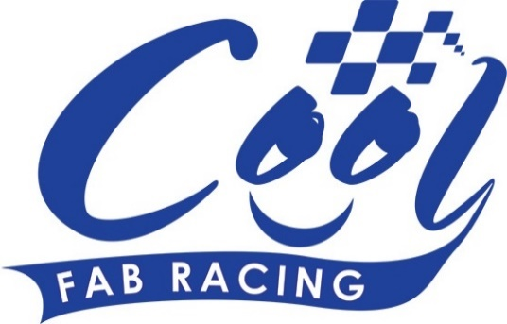
News Release

15th June 2016

All Stars Weekend for Cool FAB Championship in Llandow

Round 4 of the Cool FAB Minibikes Championship at Llandow last weekend came good on its promise of an exciting weekend with outstanding racing action and a stellar turn out.

The three-day event got under way on Friday 10th June with practice sessions followed by two full days of racing on Saturday and Sunday. Superbike rider Filip Backlund, Supersport rider Andy Reid, British F1 sidecar champions Ricky Stevens and Ryan Charlwood and Moto3 World Champion Danny Kent all made an appearance and advised the young riders trackside.

Andy Reid, who is currently leading the SuperSport championship, was attending the Cool FAB Racing British Minibikes Championship for the first time in his capacity as ambassador. He said: “What an amazing weekend at the Cool FAB Racing series in Llandow. It was a really good fun and I got a real buzz out of how competitive the racing was with some seriously action-packed races. There is genuine talent throughout the series and I will be following their progress with interest.”

The weather alternated between rain and sunshine throughout the weekend, putting the riders’ skills to the test.

Organiser of the Cool FAB Racing British Championship Roger Keys said: “Llandow proved interesting owing to the variable weather conditions but the riders took it in their stride and handled the challenge really well.

“We had some amazing racing action on the track and some surprising results too. The AC40 Rookies and the Pitbike Open were particularly exciting but all the categories were hotly contested.”

The AC40 Rookie category was once again one of the highlights of the weekend with an intense fight for the lead between Jack Kirsch and Aleksander Merchant. In the end, Merchant made it on the top step of the podium in the first two races while Kirsch won the last race.

The Pitbike Open was a source of much entertainment as Danny Kent, Frazer Rogers and Charlie Nesbitt went head to head, their lap times differing by only a fraction of a second. Nesbitt won the first race while Kent claimed top spot in the second race and Rogers came first in the last race.

In the MiniGP50, Harvey Claridge won two of the three races but Calum Beach and Scott Ogden proved worthy competitors. Holly Harris, fresh from a mentoring session with Filip Backlund, found her confidence in the wet weather conditions and noticeably improved her ranking.

Roger added: “We were delighted to welcome Filip, Andy, Ricky, Ryan and Danny to the track and it was nice to watch them interact with our young riders. They are all outstanding ambassadors for the sport.”

Filip Backlund, who races in the British Superbike, said: "It was my second time attending the Cool FAB Racing Minibikes Championship and I'm leaving Llandow with a big smile.

“It was amazing to witness the progress made by the young riders but also the infrastructure around them. I can see that since I was last here in March, there is a clear increase in the amount of fans and spectators who gather trackside to watch the racing action.

“This weekend I was also able to fully step into my ambassador role and mentor some of the young talents. To see a person that young stand and listen to my advice, take it in and then go out on track and deliver has provided me with pure satisfaction and happiness.”

For more information or to enter Round 5 of the 2016 Cool FAB Racing British Championship at Whilton Mill in Northamptonshire, please visit: www.coolfabracing.com
Ends

About Cool FAB Racing
Cool FAB Racing is a national minibikes championship run by FAB racing (www.fab-racing.co.uk) which has a long history of helping and developing young riders go from the grassroots level into British Superbikes, Moto GP and World Superbikes.
Juniors can start racing in the Cool FAB Racing British Championships from as young as 6 in the Minibike 4.2 class. By the age of 10, it is possible for riders to have come through the Minibike and MiniGP50 classes to race in the MiniGP70 series.
Cool FAB Racing graduates include MotoGP Scott Redding, former Moto3 GP champion rider Danny Kent, British Superbike rider Luke Mossey and current Hel Performance British Motostar championship leader, Charlie Nesbitt.
In 2016 FAB Racing entered into a 10-year sponsorship agreement with Cool Milk changing its name to Cool FAB Racing.

About Cool Motor Racing ltd
Cool Motor Racing Ltd is the business delivering Cool Milk’s ten-year partnership with FAB Racing. Through delivering the partnership, Cool Motor Racing Ltd is hoping to raise the profile of the Cool FAB Racing Minibike competition and position it as the training ground for British and World superbike riders, forming tighter links with the British Superbike Championship.

For further information about this news release please contact:
Kate Strawson
Shooting Star
01522 528540
07733 230293
kate@weareshootingstar.co.uk
www.weareshootingstar.co.uk
@KateStrawson
[Cool07Llandow]

