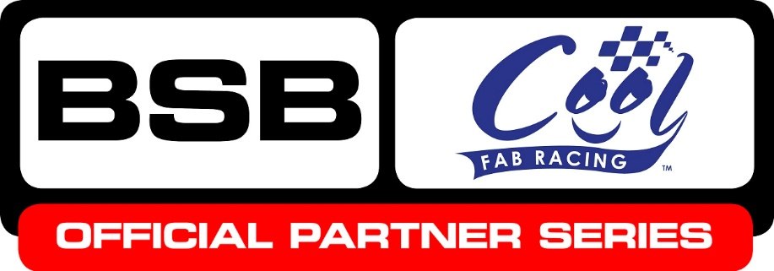

News Release

9th July 2016

Cool FAB Racing Strikes Up Official Partnership with BSB

Cool FAB Racing has formed a new partnership with the MCE Insurance British Superbike Championship to encourage more young people to get involved in motorcycle racing.

Seven BSB teams have agreed to set up junior teams to compete in the Cool FAB Racing British Minibikes Championship, now an official BSB partner series, helping to develop and support the BSB stars of the future.

These are: Tyco BMW, Quattro Plant Kawasaki, Anvil Hire TAG Yamaha, Buildbase BMW, ePayMe Yamaha, Team WD-40 and Moto Rapido Ducati.

Crispin Vitoria, Managing Director of Cool Motor Racing, the company delivering Cool Milk’s 10-year sponsorship deal with FAB Racing, said: “We have some really talented young riders competing in the Cool FAB Racing British Minibikes Championship already, and by becoming an official BSB partner series, we will be able to provide an infrastructure that will encourage more youngsters to enter the sport.

“By creating strong links between the grassroots and the very top of the sport, including the BSB riders themselves, we are able to inspire and nurture talented young riders.

“Cool FAB Racing will also provide training in safety, media training as well as racing technique, enabling those with the ability to go on to compete at a higher level.”
MCE Insurance British Superbike Championship Series Director Stuart Higgs added: The work of Cool FAB Racing is tremendously important in providing an environment for children to participate in motorcycle racing. They of course are the stars of the future and to make connection with BSB and the teams is a great initiative.”

Cool FAB Racing has long played an active role in developing young British talent. BSB rider Luke Mossey, MotoGP rider Scott Redding, 2015 Moto3 World Champion Danny Kent and current Hel Performance British Motostar championship leader Charlie Nesbitt are all graduates of the championship.

Applications for the junior superbike teams are open to any minibike rider and you don’t need to be currently racing with Cool FAB Racing to apply for a place. Already over 40 riders have put their details forward for consideration for the teams. Contact hello@coolmotorracing.com to register your interest.

Ends

About Cool FAB Racing
- The Cool FAB Racing British Minibikes Championship is run by FAB-Racing (www.fab-racing.co.uk) which has a long history of helping and developing young riders go from the grassroots level into British Superbikes, Moto GP and World Superbikes.
- Juniors can start racing in the championship from as young as 6 in the Minibike 4.2 class. By the age of 10, it is possible for riders to have come through the Minibike and MiniGP50 classes to race in the MiniGP70 series.
- In 2016 FAB Racing entered into a 10-year sponsorship agreement with Cool Milk, the UK’s leading school milk supplier, changing its name to Cool FAB Racing.

About Cool Motor Racing ltd
Cool Motor Racing Ltd is the business delivering Cool Milk’s ten-year partnership with FAB Racing. Through delivering the partnership, Cool Motor Racing Ltd is hoping to raise the profile of the Cool FAB Racing and position it as the training ground for future British and world superbike stars.
For further information please contact:
Kate Strawson
Director, Shooting Star
kate@weareshootingstar.co.uk
01522 528540
07733 230293
@Kate Strawson

