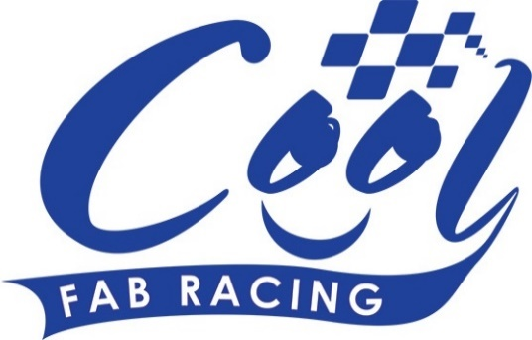
News Release

25th July 2016

Bumper Cool FAB Weekend at Whilton Mill

Following the Official BSB Partner Series launch at Snetterton earlier this month, Cool FAB Racing is hoping for a bumper turnout for Round 5 of its minibikes championship at Whilton Mill in Northamptonshire.

On Saturday 9th July Crispin Vitoria, MD of Cool Motor Racing, and MCE BSB Series Director Stuart Higgs announced the partnership in front of a crowd of excited motorcycle racing fans and journalists.

Aimed at finding the British Superbike stars of the future, the partnership will help strengthen the existing infrastructure, encouraging more youngsters to enter the sport.

Seven BSB teams have set up junior versions of their teams to compete in the Cool FAB Racing British Minibike Championship, helping to create stronger links between the grassroots and the very top of the sport.

The names of each team’s riders were picked out of a hat at random and announced on Facebook on Friday (22nd July). Those who didn’t get picked will still be able to compete in the championship and will hopefully be assigned to a team in the future as more come on board.

Crispin said there’s a lot of excitement surrounding the new partnership: “I’m really looking forward to this weekend as we’ve been working hard to put the Cool FAB’s British Minibike Championship on the map over the past couple of months, so we’re expecting a good turnout.

“We’re also going to have BSB stars Luke Mossey and Andy Reid joining us over the course of the weekend to present the trophies and give our young riders some top tips and advice. They’re also keen to compete in the PB-Open alongside the likes of Charlie Nesbitt, TJ Toms and Max Cook which should be entertaining!

“On the Saturday, Luke Mossey will be taking on Team WD-40 rider Josh Bannister, (7), who challenged him to a race live on Eurosport during the partnership launch at Snetterton!

“And of course we’ve just announced the riders who will be competing as part of a team from next season so there’s going to be a lot of excitement at this round and lots to look forward to.”

Talking about his involvement in the weekend’s events Luke said he’s really looking forward to racing on a small track again.

“I haven’t done it for years, I can’t wait! Cool Fab Racing is a massive opportunity for kids and young riders to start their racing career. I started in the exact same way by being part of the minibike championships. It’s good that these kids have this series.”

“I’m looking forward to racing against Josh, it will be interesting to see what happens on the track.”

The three-day event will get under way on Friday 29th July at Whilton Mill in Northamptonshire with practice sessions followed by two full days of racing on Saturday and Sunday. As usual Downforce Radio will be providing live commentary on the day.

For more information about Round 5 or to register to compete in one or more of the classes please visit www.coolfabracing.com

Ends

Notes to Editors:
About Cool FAB Racing
Cool FAB Racing is a national minibikes championship run by FAB racing (www.fab-racing.co.uk) which has a long history of helping and developing young riders go from the grassroots level into British Superbikes, Moto GP and World Superbikes.
Juniors can start racing in the Cool FAB Racing British Championships from as young as 6 in the Minibike 4.2 class. By the age of 10, it is possible for riders to have come through the Minibike and MiniGP50 classes to race in the MiniGP70 series.
Cool FAB Racing graduates include MotoGP Scott Redding, former Moto3 GP champion rider Danny Kent, British Superbike rider Luke Mossey and current Hel Performance British Motostar championship leader, Charlie Nesbitt.
In 2016 FAB Racing entered into a 10-year sponsorship agreement with Cool Milk changing its name to Cool FAB Racing.

About Cool Motor Racing ltd
Cool Motor Racing Ltd is the business delivering Cool Milk’s ten-year partnership with FAB Racing. Through delivering the partnership, Cool Motor Racing Ltd is hoping to raise the profile of the Cool FAB Racing Minibike competition and position it as the training ground for British and World superbike riders, forming tighter links with the British Superbike Championship.

For further information about this news release please contact:
Kate Strawson
Shooting Star
01522 528540
07733 230293
kate@weareshootingstar.co.uk
www.weareshootingstar.co.uk
@KateStrawson

