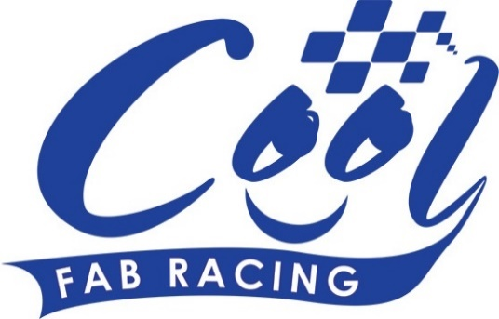
News Release

3rd August 2016

Cool FAB Enjoys a Record Turnout at Whilton Mill

Cool FAB Racing enjoyed a record turnout at Round 5 of its British minibikes championship at the weekend (29th to 31st July).

Over 300 people attended the three-day event at Whilton Mill in Northamptonshire including special guests Andy Reid and Luke Mossey, who started his motorcycle racing career competing in the Cool FAB Racing series.

As well as presenting the trophies to the winners in each class, Luke went head-to-head in a minibike race with seven-year-old Josh Bannister who threw down the gauntlet while they were both taking part in the launch of the Cool FAB Racing and MCE BSB official partnership at Snetterton in July.

There was also plenty of racing to enjoy with 13-year-old Blake Ansell from Gloucestershire claiming his first win of the season in the MiniGP 70 class and his first ever triple-win. Scott Ogden, aged 12 from Doncaster, and Franco Bourne, also aged 12 from County Durham, came second and third.

Eight-year-old Casey O’Gorman, from Dartford, celebrated a double victory after winning all three races in the MiniGP 50 and the AC40 Pro while Johnny Garness, also aged eight from Ilfracombe, won all three rounds in the AC40 Rookies.

Ten-year-old Calum Beach, from Abergele in Wales, and Scott Ogden came second and third in the MiniGP 50 while Bailey Stuart-Campbell, from Wokingham, and Evan Belford, aged nine from Tamworth, came second and third in the AC40 Pro.

In the popular Pit Bike Open, 15-year-old Charlie Nesbitt from Swindon, who’s currently in the top spot in the Motostar British Championship, came first overall followed by Fraser Rogers, who competes in the British National Superstock 1000 Championship and MotoGP rider Martin Glossop.

Commenting on the weekend Luke said: “It’s great to see so many kids all involved in Cool Fab Racing, and that they have somewhere to enjoy their passion. Being at Whilton Mill really takes me back to when I used to race here with my brother – and getting on the minibikes again was a lot of fun.”

Andy, who is currently just one point behind the leader in the British Supersport Championship, added: “The Cool FAB Racing series is a fantastic introduction to motorcycle racing for any budding young racer. The racing is competitive, yet fun and it was great to be a part of it once again at Whilton Mill. I also got the chance to go head to head with teammate Luke Mossey on the Quattro Plant Kawasaki mini-bikes which was great fun.”

Also over the weekend Dannisport, Cool FAB Racing’s official racing leathers supplier, was on site to measure the youngsters up for their new team-branded leathers. This follows on from the launch of the official partnership between Cool FAB Racing and British Superbikes (BSB), which it’s hoped will encourage more young people to get involved in motorcycle racing. As part of the deal, seven BSB teams have agreed to set up junior teams which will compete in the Cool FAB Racing British Minibikes Championship starting from 2017.

For more information about Cool FAB Racing or to register for Round 6 at Lydd, Romney Marsh, from 19th to 21st August, please visit www.coolfabracing.com

Ends

Notes to Editors:
About Cool FAB Racing
Cool FAB Racing is a national minibikes championship run by FAB racing (www.fab-racing.co.uk) which has a long history of helping and developing young riders go from the grassroots level into British Superbikes, Moto GP and World Superbikes.
Juniors can start racing in the Cool FAB Racing British Championships from as young as 6 in the Minibike 4.2 class. By the age of 10, it is possible for riders to have come through the Minibike and MiniGP50 classes to race in the MiniGP70 series.
Cool FAB Racing graduates include MotoGP Scott Redding, former Moto3 GP champion rider Danny Kent, British Superbike rider Luke Mossey and current Hel Performance British Motostar championship leader, Charlie Nesbitt.
In 2016 FAB Racing entered into a 10-year sponsorship agreement with Cool Milk changing its name to Cool FAB Racing.

About Cool Motor Racing ltd
Cool Motor Racing Ltd is the business delivering Cool Milk’s ten-year partnership with FAB Racing. Through delivering the partnership, Cool Motor Racing Ltd is hoping to raise the profile of the Cool FAB Racing Minibike competition and position it as the training ground for British and World superbike riders, forming tighter links with the British Superbike Championship.

For further information about this news release please contact:
Kate Strawson
Shooting Star
01522 528540
07733 230293
kate@weareshootingstar.co.uk
www.weareshootingstar.co.uk
@KateStrawson

