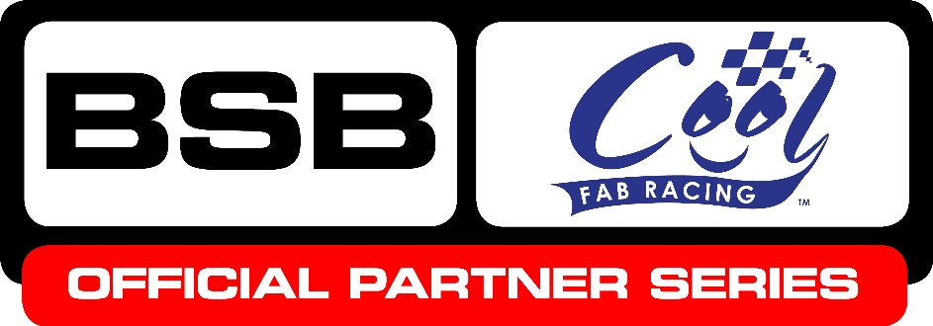

News Release

26th August 2016

Minibike Championship Sets Pulses Racing in Lydd

Pulses were racing at Lydd Kart Circuit in Kent for Round 6 of the Cool FAB Racing British Minibike Championship at the weekend.

The MiniGP 50 class was one of the highlights of the three-day competition with Corey Stainer, aged nine, from Swindon winning the first race, Harvey Claridge, 10, from Steyning, West Sussex winning the second and eight-year-old Casey O’Gorman from Dartford working his way up from 6th position to win the third.

In the MiniGP 70, last year’s MiniGP 50 champion, 10-year-old Josh Whatley from Alfreton, Derbyshire came 1st and 2nd in races one and two with Blake Ansell, 13, from Gloucestershire winning the third and setting a new lap record to boot (42.170 seconds)!

In race two Josh beat second-placed Scott Ogden, 12, from Doncaster by one thousandth of a second!

Organiser Roger Keys said it was nail-biting stuff: “We had to restrict the grid sizes as Lydd has a very small paddock area but we were still treated to a thrilling weekend of racing with one or two surprises along the way.

“The AC40 Rookies, AC40 Pro and Junior LC40 were particularly popular this round with over 18 riders competing in each of the three classes. We’ve worked hard this season to put Cool FAB Racing on the map as THE British minibike championship and we are delighted to see the numbers of riders registering increasing each round. The final at Mallory Park from 28th to 30th October promises to be a thriller.”

Also this weekend, Cool FAB Racing welcomed two young Dutch riders, Eddy De Boer and Sven Wind, who rode in the AC40 Pro. They were accompanied by Scott Deroue, previously a Grand Prix rider in the Moto3 class and now successfully competing in British Superstock 600, who was also out on track showing his ability on a senior minimoto and easily winning one of the races.

As always, one of the Quattro Plant Kawasaki team was also on hand to offer advice and support to the youngsters. This time it was the turn of sidecar passenger Ryan Charlwood.

Ryan said: “What a fantastic weekend of racing! I always enjoy coming along to these events and encouraging the riders, hopefully some of whom will go on to be the British and World Champions of tomorrow.

“As the competition moves towards the end of the season, with only two rounds remaining after this one, the rivalry is heating up as the youngsters battle it out to gain valuable points.”

For more information about Cool FAB Racing or to register please visit www.coolfabracing.com

Notes to Editors:
About Cool FAB Racing
Cool FAB Racing is a British minibike championship run by FAB racing (www.fab-racing.co.uk) which has a long history of helping and developing young riders go from the grassroots level into British Superbikes, Moto GP and World Superbikes.

Juniors can start racing in the Cool FAB Racing British Championships from as young as 6 in the Minibike 4.2 class. By the age of 10, it is possible for riders to have come through the Minibike and MiniGP50 classes to race in the MiniGP70 series.

Cool FAB Racing graduates include MotoGP class rider Scott Redding, current Moto3 World Champion Danny Kent, British Superbike rider Luke Mossey and current Hel Performance British Motostar championship leader, Charlie Nesbitt.

In 2016 FAB Racing entered into a 10-year sponsorship agreement with Cool Milk changing its name to Cool FAB Racing and became an official BSB partner series.

About Cool Motor Racing ltd
Cool Motor Racing Ltd is the business delivering Cool Milk’s ten-year partnership with FAB Racing. Through delivering the partnership, Cool Motor Racing Ltd is hoping to raise the profile of the Cool FAB Racing Minibike competition and position it as the training ground for British and World superbike riders, forming tighter links with the British Superbike Championship.

For further information about this news release please contact:
Kate Strawson
Shooting Star
01522 528540
07733 230293
kate@weareshootingstar.co.uk
www.weareshootingstar.co.uk
@KateStrawson

