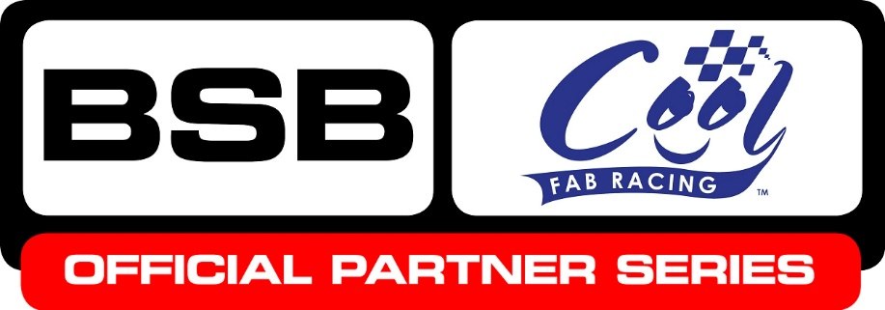

News Release

23rd September 2016

Halsall Racing Team Swaps Motorbikes for Minibikes

Halsall Racing Team, which runs the Bennetts Suzuki British Superbike squad, has launched a junior minibike team which will compete in the Cool FAB Racing British Minibike Championship in 2017.

The junior Halsall Racing team will be sponsored by Movuno.com, and is the eighth team that will compete in the championship run by Cool Motor Racing, pledging its commitment to supporting motorcycle racing at grassroots level.

Owner Martin Halsall announced the rider line-up on Saturday (17th September) at Round 10 of the MCE Insurance British Superbikes Championship at Donington Park. James Cook, 9, from Swindon; Callum Beach, 10, from Abergale in north Wales; Elliot Jones, 6, from Ollerton near Newark and Bailey Stuart-Campbell, 8, from Wokingham were selected at random from a list of hopefuls.

Martin said he’s looking forward to working with Cool Motor Racing to develop and support the BSB stars of the future: “I have a home in Spain and see the children day in day out whizzing around the circuits on the mini-motos and now that it’s taking off in the UK, I’m really keen to get involved as we know there’s a lot of talented young riders here.

“The Cool FAB Racing British Minibike Championship is so important as it provides kids with the opportunity to have a go, learn from those at the top level and find out what motorcycle racing is all about.”

Crispin Vitoria, Managing Director of Cool Motor Racing, said he’s delighted to welcome the Halsall Racing Team and Movuno.com to the championship.

“Our aim is to inspire and nurture talented young riders and provide an infrastructure that will encourage more youngsters to enter the sport,” explained Crispin. “Becoming an Official BSB Partner Series was an important step towards that and now we’re encouraging the leading teams, like Halsall Racing Team, to bring their brand into the mini-moto world.

“They provide a fantastic opportunity for our youngsters to be inspired and learn from those at the very top level of the sport and we are very grateful for their support.

“Cool FAB Racing has long played an active role in developing young British talent with the likes of Luke Mossey, Scott Redding, Danny Kent, Brad Ray and Charlie Nesbitt all coming through the sport and with the teams' help and the support of British Superbikes, we hope that we can produce even more future champions.”

Ends

About Cool FAB Racing
- The Cool FAB Racing British Minibikes Championship is run by FAB-Racing (www.fab-racing.co.uk) which has a long history of helping and developing young riders go from the grassroots level into British Superbikes, Moto GP and World Superbikes.
- Juniors can start racing in the championship from as young as 6 in the Minibike 4.2 class. By the age of 10, it is possible for riders to have come through the Minibike and MiniGP50 classes to race in the MiniGP70 series.
- In 2016 FAB Racing entered into a 10-year sponsorship agreement with Cool Milk, the UK’s leading school milk supplier, changing its name to Cool FAB Racing.

About Cool Motor Racing ltd
Cool Motor Racing Ltd is the business delivering Cool Milk’s ten-year partnership with FAB Racing. Through delivering the partnership, Cool Motor Racing Ltd is hoping to raise the profile of the Cool FAB Racing and position it as the training ground for future British and world superbike stars.
About Movuno.com
- Online estate agency Movuno.com sponsors Halsall Racing and the Bennetts Suzuki British Superbike team.
- Using the latest technology Movuno.com removes many of the overheads associated with selling or buying a home through a high street estate agency saving the customer money without compromising on service

For further information please contact:
Kate Strawson
Director, Shooting Star
kate@weareshootingstar.co.uk
01522 528540
07733 230293
@Kate Strawson

