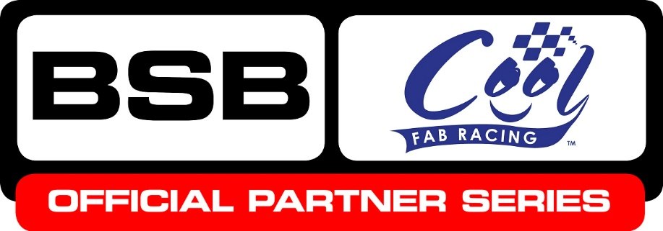

News Release

13th October 2016

Cool FAB Minibike Series Revs Up a Gear at Red Lodge

The penultimate round of the Cool FAB Racing British Minibike Championship at Red Lodge Karting at the weekend saw 10-year-old Harvey Claridge secure the MiniGP 50 2016 championship after a close fought battle on the track.

Harvey, from Steyning, West Sussex, increased his lead by an impressive 111 points to 446 after winning race two and coming second in the other two races behind Corey Stainer.

Corey, aged nine from Swindon, was awarded 70 points after a fantastic weekend of racing but failed to move up the championship table, remaining in fourth with 216 points.

Calum Beach (10) from Abergele in Wales remains in second place on 333 points followed by Scott Ogden, aged 12 from Doncaster, who is just one point behind!

In the MINI GP 70 there’s still everything to race for with Franco Bourne, aged 12 from County Durham, just managing to hang on to his championship lead after coming third in race one and two, and fourth in race three.

Ten-year-old Joshua Whatley from Alfreton in Derbyshire put in a stunning performance on the track, storming up the table into second place, just four points behind Franco, after winning all three races and securing 75 points! Scott Ogden remains in third.

Josh has also clinched the Junior LC40 the championship title, despite not competing in the class at this round to give the other riders the chance to get maximum points, with a 113-point lead over second-placed Evan Belford.

In the popular Pit Bike Open, the 2016 HEL Performance British Motostar Championship winner and former Cool FAB Racing champion Charlie Nesbitt, aged 15 from Swindon, won two races and came second in race one, gaining 70 points which secured him the championship title.

Visitors to Red Lodge also got to meet British Supersport riders Andy Reid and Brad Ray.

MD of Cool Motor Racing Crispin Vitoria said if Red Lodge was anything to go by the final round at Mallory Park looks like being a nail-biter!

“Apart from the MiniGP 50, which saw the amazingly talented Harvey Claridge clinch the championship title after a really strong performance, the Junior LC40 and the Pit Bike Open, the winners of the Cool FAB Racing 2016 championship are still be decided which makes for an exciting finale,” said Crispin. “And of course we’re looking forward to finding out who is going to end the season in second and third in all of the classes.

“We’ve also got some very special guests lined up for Mallory Park from the world of British Superbikes and lots of fun activities planned to make sure the 2016 series really ends on a high note."

The winners from round 7 of the Cool FAB British Minibike Championship will be presented with their trophies on the podium at round 12 of the MCE BSB championship at Brands Hatch on Saturday, 15th October at 13:45.

For more information on Cool FAB Racing please visit www.coolfabracing.com or follow @CoolFABRacing on Twitter or Facebook.

Ends

About Cool FAB Racing
- The Cool FAB Racing British Minibikes Championship is run by FAB-Racing (www.fab-racing.co.uk) which has a long history of helping and developing young riders go from the grassroots level into British Superbikes, Moto GP and World Superbikes.
- Juniors can start racing in the championship from as young as 6 in the Minibike 4.2 class. By the age of 10, it is possible for riders to have come through the Minibike and MiniGP50 classes to race in the MiniGP70 series.
- In 2016 FAB Racing entered into a 10-year sponsorship agreement with Cool Milk, the UK’s leading school milk supplier, changing its name to Cool FAB Racing.

About Cool Motor Racing ltd
Cool Motor Racing Ltd is the business delivering Cool Milk’s ten-year partnership with FAB Racing. Through delivering the partnership, Cool Motor Racing Ltd is hoping to raise the profile of the Cool FAB Racing and position it as the training ground for future British and world superbike stars.

For further information please contact:
Kate Strawson
Director, Shooting Star
kate@weareshootingstar.co.uk
01522 528540
07733 230293
@Kate Strawson

