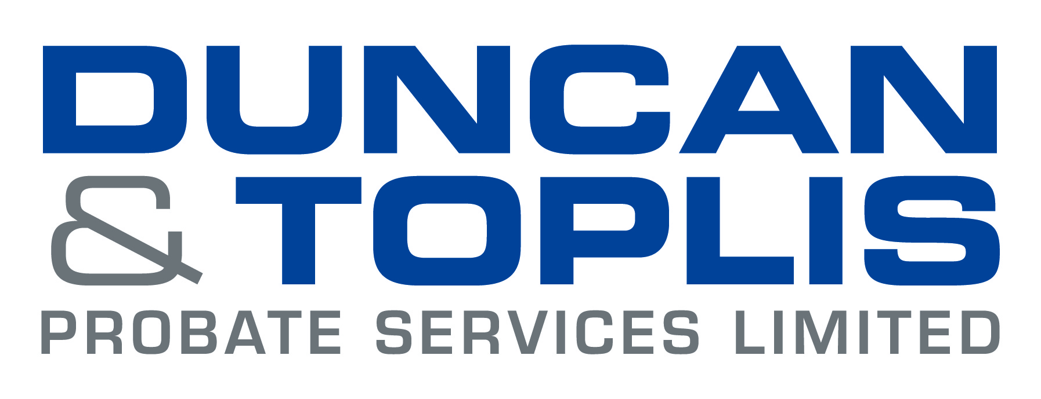

News release

Date

Trust Duncan & Toplis for Probate Peace of Mind

People facing the death of a friend or loved one can now turn to one of the largest independent firms of chartered accountants in the Midlands to administer the deceased person’s estate.

ICAEW East Midlands Medium Accountancy Firm of the Year Duncan & Toplis has established a sister company, Duncan & Toplis Probate Services Limited, to provide specialist assistance to clients in all non-contentious probate matters.

Duncan & Toplis Probate Services Limited offers a bespoke service, able to assist clients with specific probate tasks or to guide them through the whole process from beginning to end.

Graeme Hills, Head of Legal Practice at Duncan & Toplis Probate Services Limited, said: “The administration of an estate can be a daunting task, especially at such a difficult time. We are here to lighten that burden, using our experience and expertise to look after the estate and guide you through the process.

“Our service is an all-encompassing one for non-contentious probate cases – covering collecting in of the assets; estate administration; calculating inheritance tax liabilities and ensuring all inheritance tax reporting submissions are met; applying for grant of probate; preparation of estate accounts and distribution of the estate.”

Adrian Reynolds, Managing Director at Duncan & Toplis, said: “Duncan & Toplis has been assisting solicitors with probate work for many years.

“When a change in regulatory framework allowed accountants to carry out this work from September 2014, we saw this as an opportunity for us to assist our clients fully, and therefore simplify the process for clients.”

He added: “As well as being authorised by the ICAEW, our team are also experienced tax professionals – therefore we are able to assist with all matters of inheritance tax, income tax, capital gains tax and trust tax that may arise.”

If you would like to discuss Duncan & Toplis Probate Services Limited and how they can be of assistance, please contact 01476 591200 or email Graeme.Hills@duntop.co.uk

Ends
Notes to editors:

- Duncan & Toplis Probate Services Limited (a sister company of Duncan & Toplis) was established in January 2016.
- Duncan & Toplis Probate Services Limited is licensed and authorised by the Institute of Chartered Accountants in England and Wales (ICAEW) to carry out the reserved legal activity of non-contentious probate in England and Wales.
- ‘Non-contentious’ in this context refers to nobody contesting the distribution terms through the will/intestacy rules. Therefore, provided no one is disputing their entitlement, Duncan & Toplis Probate Services Limited can act. If a point of contention arises during the time of acting, Duncan & Toplis Probate Services Limited will refer the case to a solicitor until the point of contention is resolved.

For media information please contact:
Jonny Hall
Shooting Star
01522 528540
jonny@weareshootingstar.co.uk
[Duncan125Probate]

