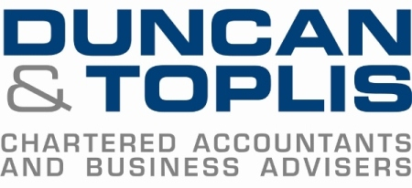
News release

11th July 2016

Gingerbreads Score Another Goal with Duncan & Toplis

East Midlands accountancy firm Duncan & Toplis is swapping spreadsheets for clean sheets by sponsoring Grantham Town Football Club for the 15th consecutive year.

The firm, which has offices in Lincolnshire, Leicestershire and Nottinghamshire has recently renewed its partnership with the club for the upcoming 2016-17 EVO-STIK Northern Premier League season.

Throughout the years that Duncan & Toplis has sponsored Grantham Town Football Club, the firm has been on hand to offer help and advice and support the organisation, which was founded in 1874.

Ian Phillips is Deputy Managing Director for Duncan & Toplis, based in Newark, and is an avid supporter of the Gingerbreads.

He said: “We are proud sponsors of the football club and have witnessed both its highs and its lows, which are similar to those that many of our commercial clients also face.

“Through our sponsorship deal, we will maintain our contribution to the continuity of this historic organisation.

“A new season brings fresh optimism both on the field and off and we always look forward to playing our part in helping the club be a success – financially, at least!

“We wish the club and everyone associated with it all the best for the coming months.”

Grantham Town Director and Development Manager, Sophie Cope, added: “It’s fantastic to have once again secured the support of a local business which offers vital services free of charge and shows a genuine interest in the development of the football club. It really does go a long way to helping us behind the scenes.”
Sponsoring Grantham Town Football Club is just one part of the commitment by Duncan & Toplis to the community; the company also champions local causes and initiatives wherever possible by offering financial support to various organisations and individuals as well as hosting annual charity fundraising events.

Ends
Notes to editors:
- Duncan & Toplis was established in 1925 and has since grown into one of the largest independent firms of chartered accountants in the Midlands.
- The company appears in the top 40 UK accountancy practices list published by Accountancy Age.
- Duncan & Toplis was named ICAEW East Midlands Medium Accountancy Firm of the Year in March 2014, 2015 and 2016.
- The company has 11 offices throughout the East Midlands: in Boston, Grantham, Lincoln, Loughborough, Louth, Melton Mowbray, Newark, Skegness, Sleaford, Spalding and Stamford.
- Duncan & Toplis offers a wide range of services to small and large-sized family businesses, from accountancy, audit and tax to payroll, human resources and computer services.
- The business employs around 370 staff, of whom 85 are currently engaged in professional training.
- Duncan & Toplis is a member of Kreston International, the global network of independent accounting firms. Kreston UK, a brand representing firms based in the UK, Ireland, Channel Islands and Isle of Man, provides national coverage, a resource of over 1,950 professional and support staff and generates annual fee revenues of £122m. As a combined organisation, it would rank as the 11th largest UK firm.

For media information please contact:
Mike Shields
Shooting Star
01522 528540
mike@weareshootingstar.co.uk
[Duncan143GTFCSponsorship]

