News release

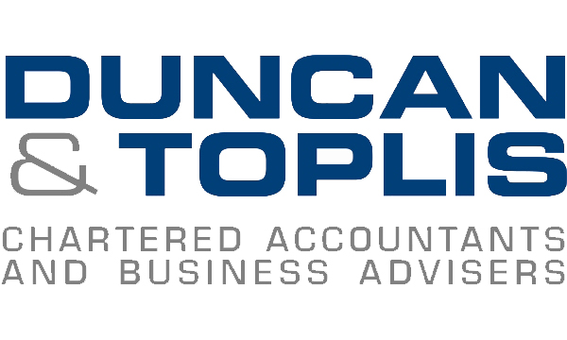
18th October 2016

Chartered Accountants Champion Six Charities in September

Colleagues at Duncan & Toplis spent September enjoying lots of cake and exercising it off to fit in their jeans - and raised over £3,500 for charity in the process!

Last month was especially busy for the leading East Midlands accountancy firm, as the teams at each of its 11 offices took part in a series of charity fundraising events.

To kick off the month, colleagues at the Boston office helped Sarah Clyde, Director at Duncan & Toplis and treasurer for Boston and District Macmillan Cancer Support, organise an annual charity golf day for the cause.

This raised a total of £2,610.45 and was topped up by £290 when teams at the Stamford and Loughborough offices held Macmillan coffee mornings for team members and clients.

Those in Melton Mowbray got into the charity spirit by raising £90 for their chosen cause – young suicide prevention charity Papyrus – during a bake off competition.

From 12th until 16th September, the team in Louth also got creative in the kitchen, holding a bake off competition which raised £50 for the British Heart Foundation.

During the same week, colleagues from the Lincoln, Grantham and Newark offices formed a team and took part in the annual charity rounders match at Woodland Waters on Wednesday 14th September. This raised a total of £400, including a £100 contribution from the Duncan & Toplis team, which was donated to The Brain Tumour Charity.

During the following week, on Friday 23rd September, each office donned their jeans and raised a total of £300 in aid of Jeans for Genes Day.

Finally, to round off a month of fundraising activity, four colleagues from the Newark office launched Newark Young Professionals on Thursday 29th September. The group raised £500 from proceeds gathered during the raffle and a quiz on the night, which was donated to the Queen’s Medical Centre in Nottingham.

Director and Head of Marketing at Duncan & Toplis, Tom Hindmarch, said: “I am so impressed with the efforts of all of my colleagues and am extremely proud that we have raised so much for so many worthy causes.

“However, it doesn’t stop there. We are hoping to raise even more through our ongoing office bake off competitions, as well as various other activities we have planned throughout the rest of the year.”

Most recently Marketing Assistant Emily Baker-Gaunt and trainee accountant Jessica Beeston took part in the Lincoln Half-Marathon on Sunday 2nd October, raising £565 for their chosen charities, St Barnabas and Cancer Research UK.

The firm is also taking part in Wear It Pink day on Friday 21st October in aid of Breast Cancer Now and Christmas Jumper Day on Friday 16th December to raise money for Save the Children.

You can follow the company’s fundraising activities via www.twitter.com/duncantoplis.

Ends
Notes to editors:
- Duncan & Toplis was established in 1925 and has since grown into one of the largest independent firms of chartered accountants in the Midlands.
- The company appears in the top 40 UK accountancy practices list published by Accountancy Age.
- Duncan & Toplis was named ICAEW East Midlands Medium Accountancy Firm of the Year in March 2014, 2015 and 2016.
- The company has 11 offices throughout the East Midlands: in Boston, Grantham, Lincoln, Loughborough, Louth, Melton Mowbray, Newark, Skegness, Sleaford, Spalding and Stamford.
- Duncan & Toplis offers a wide range of services to small and large-sized family businesses, from accountancy, audit and tax to payroll, human resources and computer services.
- The business employs around 370 staff, of whom 85 are currently engaged in professional training.
- Duncan & Toplis is a member of Kreston International, the global network of independent accounting firms. Kreston UK, a brand representing firms based in the UK, Ireland, Channel Islands and Isle of Man, provides national coverage, a resource of over 1,950 professional and support staff and generates annual fee revenues of £122m. As a combined organisation, it would rank as the 11th largest UK firm.

For media information please contact:
Zoe Lamb
Shooting Star
01522 528540
zoe@weareshootingstar.co.uk
[Duncan154CharityMonth]

