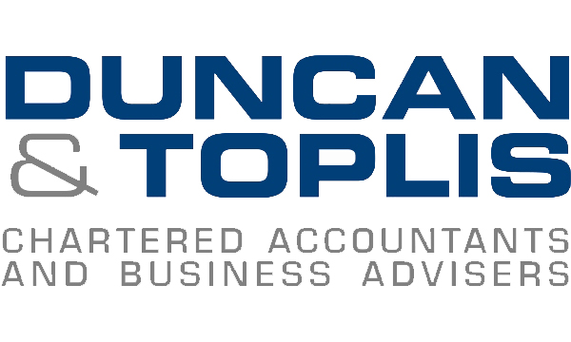

News release

15th February 2017

John Joins the Duncan & Toplis Team in Sleaford

Chartered accountants Duncan & Toplis have added to their team in Sleaford with the appointment of Manager John Raynor.

Having worked in accountancy since 2003 after a change from a career in manufacturing, John (34) brings experience in improving systems and procedures as well as reducing tax liability for clients. He is also familiar with sourcing and planning finance and reducing annual compliance stresses for businesses.

John said: “Accountancy is my life’s vocation and I love learning about a wide range of businesses. I feel that to best help a client, you really need to know their business.”

John’s experience also involves working on audits in large companies with a turnover in excess of £60 million, and he has also specialised in academies, charities and pension schemes.

John added: “My role has taken me through differing levels of general practice from small tax returns to large specialised audit assignments. My role now, as a manager, is focused on helping a portfolio of clients ranging from sole trader accounts through to audits and pure taxation clients.”

John will be based at the Sleaford office, but will also be working with clients in other offices too.

Ends

Notes to editors:
- Duncan & Toplis was established in 1925 and has since grown into one of the largest independent firms of chartered accountants in the Midlands.
- The company appears in the top 40 UK accountancy practices list published by Accountancy Age.
- Duncan & Toplis was named ICAEW East Midlands Medium Accountancy Firm of the Year in March 2014, 2015 and 2016.
- The company has 11 offices throughout the East Midlands: in Boston, Grantham, Lincoln, Loughborough, Louth, Melton Mowbray, Newark, Skegness, Sleaford, Spalding and Stamford.
- Duncan & Toplis offers a wide range of services to small and large-sized family businesses, from accountancy, audit and tax to payroll, human resources and computer services.
- The business employs around 370 staff, of whom 85 are currently engaged in professional training.
- Duncan & Toplis is a member of Kreston International, the global network of independent accounting firms. Kreston UK, a brand representing firms based in the UK, Ireland, Channel Islands and Isle of Man, provides national coverage, a resource of over 1,950 professional and support staff and generates annual fee revenues of £122m. As a combined organisation, it would rank as the 11th largest UK firm.

For media information please contact:
Mike Shields
Shooting Star
01522 528540
mike@weareshootingstar.co.uk
[Duncan160JohnRaynor]

