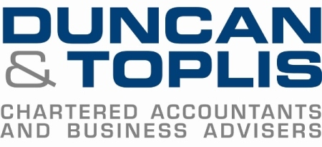

News release

20th March 2017

Duncan & Toplis Named Large Accountancy of the Year

The team at Duncan & Toplis are toasting its success after being named as Large Accountancy Firm of the Year 2017 for the first time.

The prize, awarded by the East Midlands ICAEW (Institute of Chartered Accountants in England and Wales), comes after the firm’s previous reign as Medium Accountancy Firm of the Year – a title they held three years in a row.

The awards, handed out each year, seek to celebrate the success of regional ICAEW firms, with the large accountancy firm award only open to practices with 26 or more partners or principals.

Adrian Reynolds, Managing Director at Duncan & Toplis, said: “We’re delighted to have been awarded this prestigious title and it adds to what has already been an exciting year for the firm. We have promoted some of our promising individuals to director level recently and we are looking forward to developing our future growth as a firm.

“The promotions, combined with our continuing focus on supporting new generations in the form of graduates and trainees, sit alongside our drive to adopt technology and innovation in delivering our services. We feel this will properly equip us to meet the challenges the business world will inevitably face over the coming years.”

The firm was handed the prize at the annual ICAEW dinner at Eastwood Hall, Nottingham, on Friday (17th March). Duncan & Toplis was judged to be the firm that has made the most significant contribution to the economic prosperity of the East Midlands in over the past year.

The judges looked at several criteria, including business success, contribution to the local economy and the firm’s involvement in the wellbeing of the region’s residents through charitable and voluntary activities.

Ends

Notes to editors
- Duncan & Toplis was established in 1925 and has since grown into one of the largest independent firms of chartered accountants in the Midlands.
- The company appears in the top 40 UK accountancy practices list published by Accountancy Age.
- Duncan & Toplis was named ICAEW East Midlands Medium Accountancy Firm of the Year in March 2014, 2015 and 2016.
- The company has 11 offices throughout the East Midlands: in Boston, Grantham, Lincoln, Loughborough, Louth, Melton Mowbray, Newark, Skegness, Sleaford, Spalding and Stamford.
- Duncan & Toplis offers a wide range of services to small and large-sized family businesses, from accountancy, audit and tax to payroll, human resources and computer services.
- The business employs around 370 staff, of whom 85 are currently engaged in professional training.
- Duncan & Toplis is a member of Kreston International Ltd, a global network of independent accounting firms that combine expertise with empathy to provide compliance and advisory services that help individuals and their organisations to achieve their professional goals. Founded in 1971 and currently the 12th largest accounting network in the world, Kreston comprises 180 firms in 113 countries. As a single, seamless network, it provides a consistently exceptional service to clients all over the world.

For media information please contact:
Mike Shields
Shooting Star
01522 528540
mike@weareshootingstar.co.uk
[Duncan163ICAEW]

