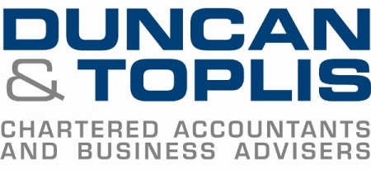

News release

12th June 2017

How Much Do You Know About Making Tax Digital?

Are you ready for Making Tax Digital (MTD), which is likely to be introduced from next year? Chartered Accountants Duncan & Toplis want to know how prepared businesses and landlords are for the changes.

The firm is running a survey throughout June and July inviting businesses and those with an interest in tax matters to contribute. Those who take part will be entered into a draw to win an iPad.

Making Tax Digital is a key part of the Government’s plans to make it easier for individuals and businesses to get their tax right and keep on top of their affairs. The changes will mean a shift to quarterly reporting of information to HMRC instead of annual tax returns.

Matt Herd, Associate Director and Chair of Making Tax Digital at Duncan & Toplis, said: “With such significant changes being introduced over the next few years, we want to know how people feel in terms of how they’ve been informed and what concerns they have.

“Because businesses rely on their accountants for guidance, we want to know which elements they are aware of already. We feel those who are not prepared to report digitally may struggle once the changes come in so it’s best to start thinking about it now.”

The Government announced its vision for modernising the tax system in the 2015 Budget. In 2017 it was announced that 3.1 million small businesses would be given an extra year (until 2019) before they are required to keep digital records and send HMRC quarterly updates.

Matt added: “Every individual and business now has access to their own personalised digital tax account and these are being regularly expanded and improved. We want to know if anyone has encountered problems in this regard and whether they face challenges to meet this new way of approaching tax.

“For example, many will have to look into what impact this will have on their business in terms of the cost of updating software, staffing or provision for bookkeeping and accounting services.”

The survey is live and you can take part by going to www.surveymonkey.co.uk/r/makingtaxdigitalsurvey

Ends

Notes to editors
- Duncan & Toplis was established in 1925 and has since grown into one of the largest independent firms of chartered accountants in the Midlands.
- The company appears in the top 40 UK accountancy practices list published by Accountancy Age.
- Duncan & Toplis was named ICAEW East Midlands Large Accountancy Firm of the Year in March 2017, having previously held the title of Medium Accountancy Firm of the Year in 2014, 2015 and 2016.
- The company has 11 offices throughout the East Midlands: in Boston, Grantham, Lincoln, Loughborough, Louth, Melton Mowbray, Newark, Skegness, Sleaford, Spalding and Stamford.
- Duncan & Toplis offers a wide range of services to small and large-sized family businesses, from accountancy, audit and tax to payroll, human resources and computer services.
- The business employs around 370 staff, of whom 85 are currently engaged in professional training.
- Duncan & Toplis is a member of Kreston International Ltd, a global network of independent accounting firms that combine expertise with empathy to provide compliance and advisory services that help individuals and their organisations to achieve their professional goals. Founded in 1971 and currently the 12th largest accounting network in the world, Kreston comprises 180 firms in 113 countries. As a single, seamless network, it provides a consistently exceptional service to clients all over the world.

For media information please contact:
Mike Shields
Shooting Star
01522 528540
mike@weareshootingstar.co.uk
[Duncan171MTD]

