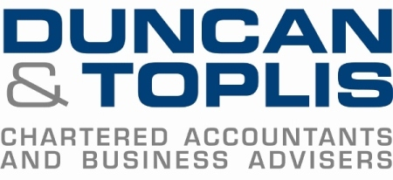

News release
24th November 2014

Uncertainty is the New Norm, Says Chamber Boss

Businesses need to be ready to deal with uncertainty, which is now the new norm in the UK economy.

That was the message delivered at the annual Duncan & Toplis Directors’ Briefing by John Longworth, Director General of the British Chambers of Commerce.

He said national referenda, the likelihood of future hung Parliaments, global conflicts and the possibility that the UK might leave the EU mean doing business in the UK is no longer in any sense predictable.

But he painted an optimistic picture for UK businesses while calling for more effort to be made to support and promote UK exporting.

“The new norm in the economy is uncertainty, but businesses must accept that new norm and get over it,” he told delegates.

“What we really must do is something radically different to support and promote UK exporting.”

Over 120 senior business people attended the Directors’ Briefing at the Belton Woods Hotel near Grantham on Friday (21st November 2014).

Other speakers included Neil Rhodes, Chief Constable of Lincolnshire Police; Emma McClarkin MEP; Yo Yo Noodles entrepreneur Eric Ho; Kevin Igoe, Managing Director of Professional Fee Protection Limited; Mike Rigby, National Head of Manufacturing, Transport and Logistics at Barclays; and David Gratton, a Director of Duncan & Toplis.

One delegate attending the event for the first time was Mike Stokes of networking organisation The Business Club.

“I’ve thoroughly enjoyed it – there was a good range of speakers who presented with great interest and humour,” he said.

“I will take away the optimism of the speakers, particularly Mike Rigby. The press are always talking down the economy so a little optimism was good to hear!

“It was also a great networking opportunity and I’ll definitely come again.”

Chris Brown, Business Development Manager at solicitors Andrew & Co, said: “There were some very good talks, particularly the one on tax and HMRC by Kevin Igoe. It could have been a bit technical but he put a nice spin on it and made it very interesting and enjoyable.

“This is the first time I’ve been to the Directors’ Briefing, but I will definitely come back and I will be recommending to other people to attend next year’s event!”

Notes to editors
- Duncan & Toplis was established in 1925 and has since grown into one of the largest independent firms of chartered accountants in the Midlands.
- The firm was named ICAEW East Midlands Medium Accountancy Firm of the Year in March 2014.
- Duncan & Toplis appears in the top 40 UK accountancy practices list published by Accountancy Age.
- The company has 10 offices throughout the East Midlands: in Grantham, Boston, Lincoln, Louth, Melton Mowbray, Newark, Skegness, Sleaford, Spalding and Stamford.
- Duncan & Toplis offers a wide range of services to small to large-sized family businesses, from accountancy, audit and tax to payroll, human resources and computer services.
- The business employs around 350 staff, of whom 85 are currently engaged in professional training.
- This was the sixth annual Directors’ Briefing, a free event which offers high-level advice from leading business leaders and the chance to hear from and meet with knowledgeable speakers.

For media information please contact
Jez Ashberry
Shooting Star PR
01522 528540
07780 735071
jez@shootingstar-pr.co.uk
[Duncan91briefing]

