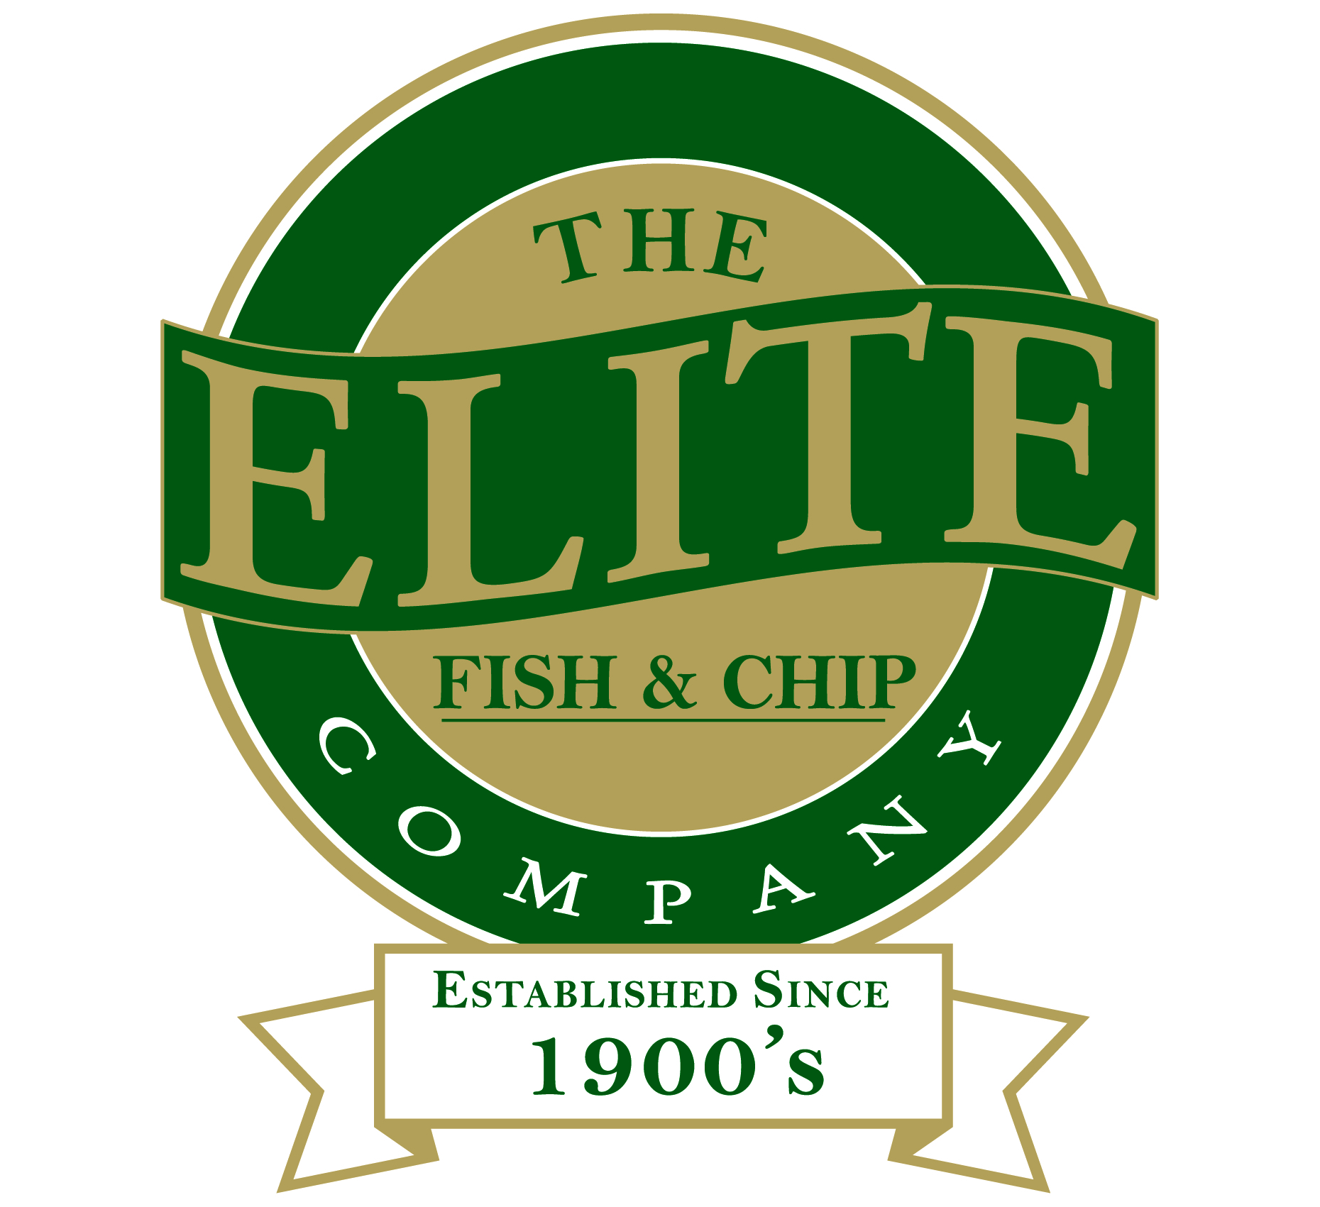
News release
13th February 2015

Elite’s Frying High With Quality Fish & Chips Award

The Elite Fish and Chip Company is celebrating after being recognised with the prestigious National Federation of Fish Friers (NFFF) Fish & Chip Quality Award.

The award identifies fish and chip outlets that serve the highest quality fish and chips following a thorough assessment of the premises, equipment, working practices, hygiene standards and management controls, along with the quality and taste of cooked fish and chips.

Head Fryer Mark Soper said: “Winning the NFFF Fish & Chip Quality Award is a great achievement in the fish and chip industry and we are thrilled to have received it.

“We work very hard to provide our customers with the best quality fish and chips,” continued Mark. “Every detail of our food preparation was scrutinised, from the sustainable fish we source to the fresh potatoes that we prepare for our chips.

“As a result we’re delighted to have excelled and be recognised by the industry experts for delivering top quality fish and chips.”

The assessment at the fish and chip restaurant and takeaway on Tritton Road in Lincoln was conducted by a highly trained and approved NFFF auditor.

NFFF Training and Accreditation Manager Richard Wardell explained: “The NFFF Fish & Chip Quality Award assessment is extremely comprehensive. Food safety is a key area that we examine together with other key aspects of the business including the preparation and cooking equipment, to the management of paperwork and traceability of fish.

“The Elite Fish and Chip Company clearly takes pride in where it sources its fish and potatoes from,” said Richard. “Achieving the NFFF Fish & Chip Quality Award provides reassurance to customers of The Elite Fish and Chip Company that they are being served cooked food using high-quality ingredients.”

The Elite Fish and Chip Company has restaurants and takeaways in Lincoln, Ruskington and Sleaford which are all recognised with the NFFF Fish & Chip Quality Award and have five-star Food Standards Agency (FSA) hygiene ratings.

Mark added: “Our restaurants and takeaways are one of only three fish and chip companies in Lincolnshire to be granted the NFFF Fish & Chip Quality Award, making our achievement even more significant.”

Currently around 250 fish and chip outlets across the country have been recognised with the NFFF Fish & Chip Quality Award.
Ends

Follow us on Twitter: www.twitter.com/chippyelite
Find us on Facebook: www.facebook.com/elitefishandchipcompany

Notes to editors:
- The Elite Fish and Chip Company has three restaurants and takeaways in Lincoln, Sleaford and Ruskington.
- It has been serving fish and chips in Lincolnshire for over 40 years.
- It is a family-owned business in its third generation of fryers.
- The Elite Fish and Chip Company won the National Fish and Chip shop of the year in 1992.
- The NFFF Fish and Chip Quality Award launched in 2011, replacing the Seafish Friers Quality Award. The scheme is aimed at improving the standard of fish and chips on a national level, and reward shops that provide top quality food to customers in a clean and hygienic environment. It also assures the public that awarded fish and chip shops promote environmental safety, by purchasing fish from sustainable sources.

