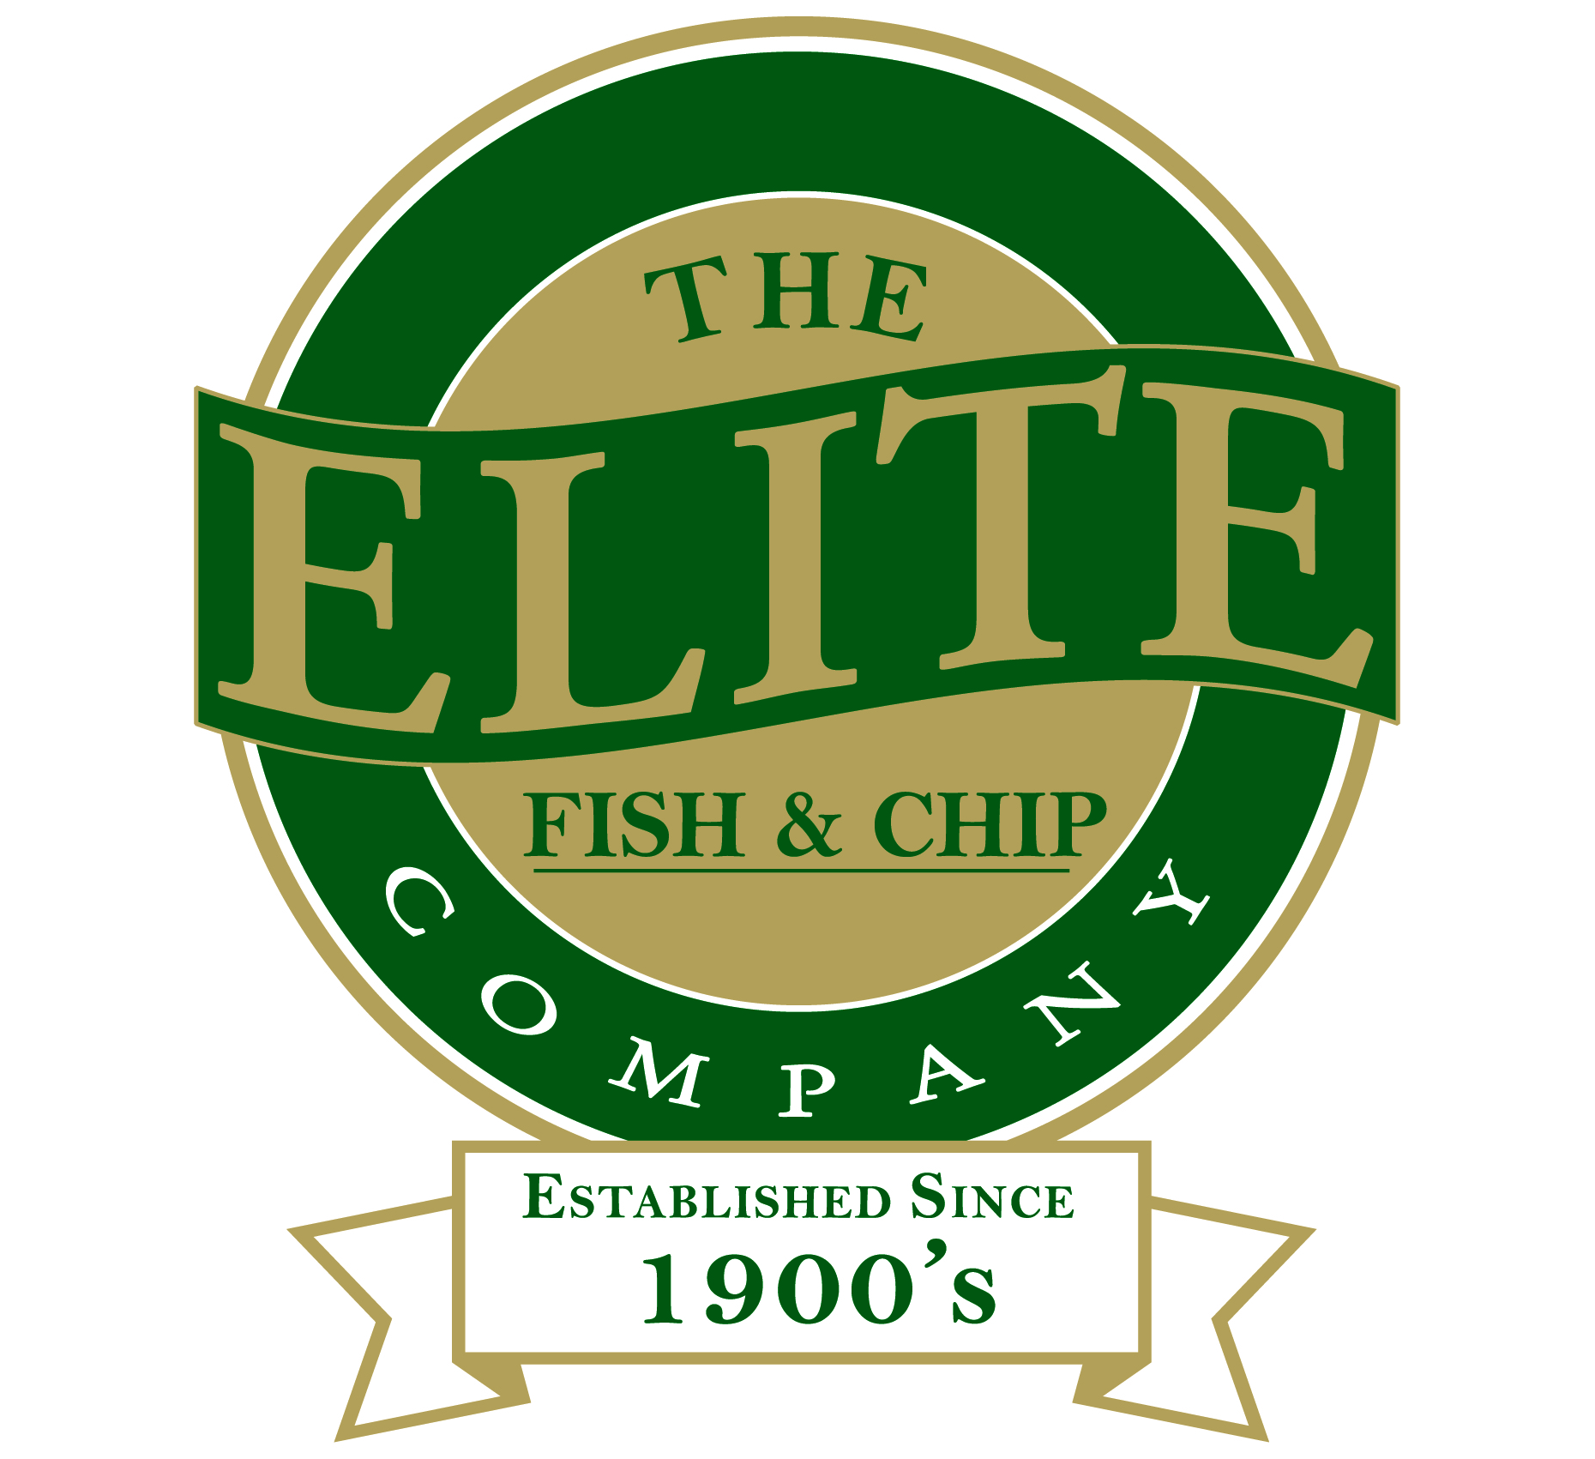

News release
20th January 2015

Sleaford’s Elite Young Frier Reels in Top Industry Award

Rachel Tweedale of The Elite Fish and Chip Company has been crowned Young Fish Frier of the Year at the National Fish and Chip Awards today (Tuesday 20th January).

The prestigious award celebrates the best young friers across the country and encourages them to nurture their skills and talents to become positive role models for others within the industry.

Rachel (25), who manages the Sleaford Elite Fish and Chip restaurant and takeaway, will be an ambassador for the Drywite Young Fish Friers competition, which supports and showcases the best young friers in the UK.

“After reaching the final six of the nation’s top young friers it’s great to win the award and be named Young Fish Frier of the Year,” said Rachel after she was presented with her trophy in London.

“I’m looking forward to promoting the competition to young people within our sector and encouraging more people to consider our industry as a career path. It’s been a great opportunity to learn new skills, meet new people and expand my career.”

To reach the final stage of the competition Rachel and the five other contestants were heavily scrutinised at a strict test day at the National Federation of Fish Friers (NFFF) Training School in Leeds.

Candidates were reviewed on their fish and chip preparation and frying techniques and completed personal skills-based tests which were judged by four separate judging panels.

Rachel added: “Thank you to all the customers and staff at The Elite Fish and Chip Company who showed their support throughout the competition. It was a great experience with lots of learning opportunities, but it also put my skills to the test. I have gained a huge amount of invaluable industry knowledge that will help me develop my career and The Elite Fish and Chip Company.”

The Young Fish Frier of the Year Award was one of 13 categories at the National Fish & Chip Awards on Tuesday 20th January 2015.

Find out more about the awards at http://www.fishandchipawards.com/

Ends

Follow us on Twitter: www.twitter.com/chippyelite
Find us on Facebook: www.facebook.com/elitefishandchipcompany

Notes to editors:
- The Elite Fish and Chip Company has three restaurants and takeaways in Lincoln, Sleaford and Ruskington.
- It has been serving fish and chips in Lincolnshire for over 40 years.
- It is a family-owned business in its third generation of fryers.
- The Elite Fish and Chip Company won the National Fish and Chip shop of the year in 1992.

Contact:
Sarah Howells
01522 528540
Sarah@shootingstar-pr.co.uk
@sarahhowellspr

