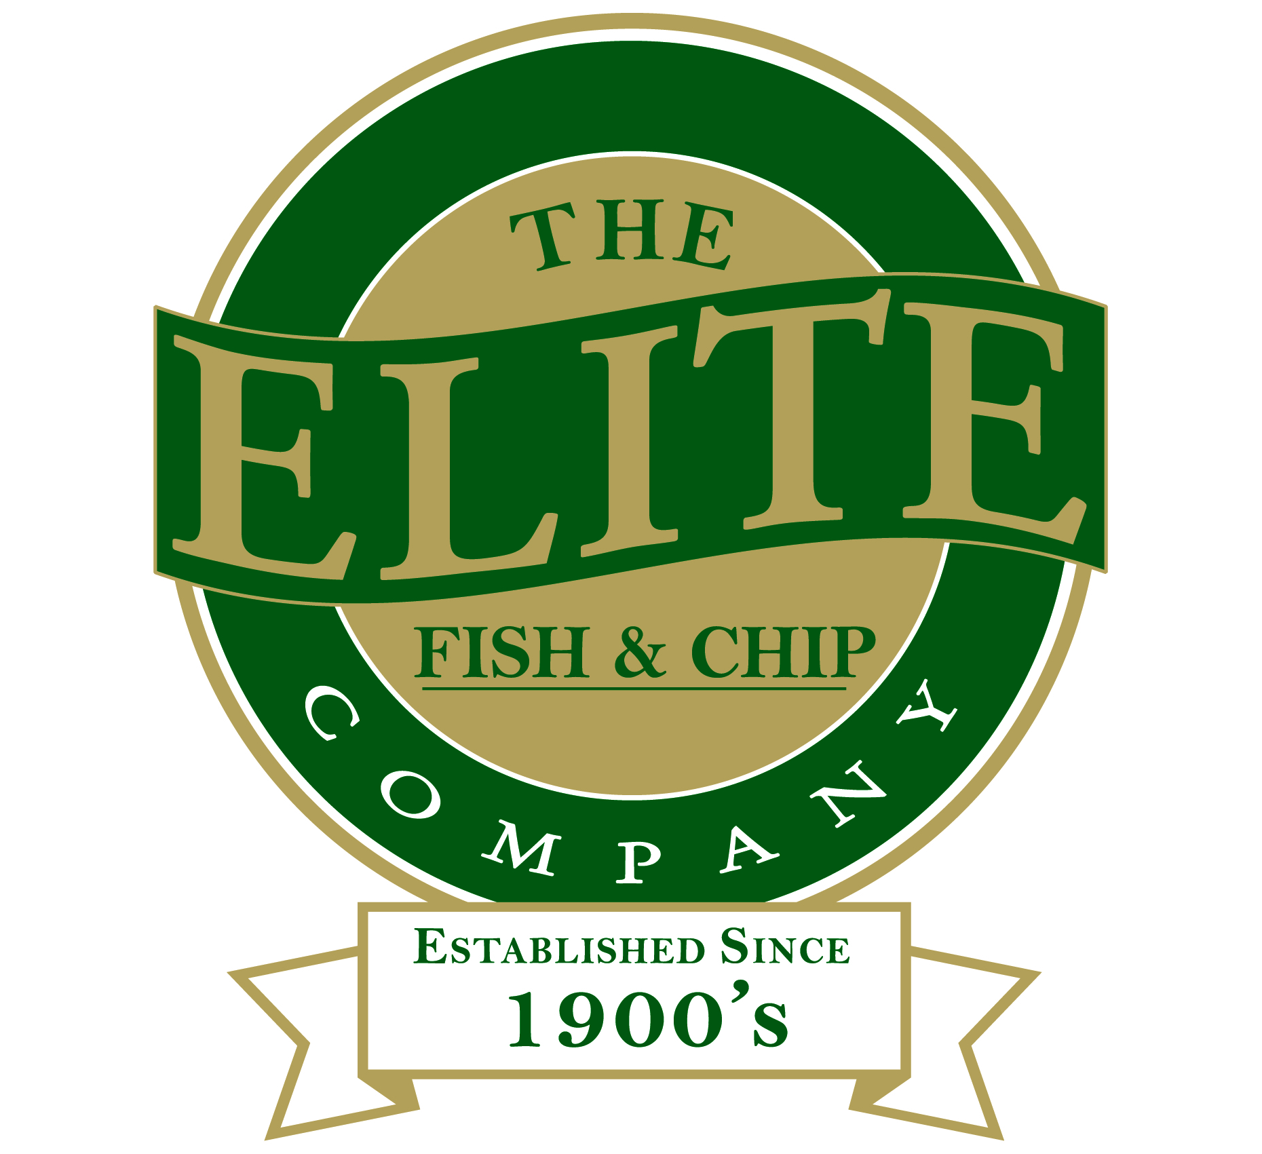

News release
16th February 2015
County’s Best Chippy Chips are Elite

Chip lovers have voted The Elite Fish and Chip Company in Lincoln home of the ‘Best Chippy Chips’ in Lincolnshire.

The annual Choice Chip Awards is run by the Potato Council every year in recognition of Chip Week (16th to 22nd February 2015) to find the tastiest chips across the UK, as voted for by customers.

Mark Soper, Head Fryer at The Elite Fish and Chip Company in Lincoln, said: “Thank you so much to all our chip-loving customers who took the time to vote for us to win the Best Chippy Chips awards!

“We use locally sourced potatoes and cut our chips to the perfect width so they don’t absorb too much fat and they are served crispy and delicious – just as proper chippy chips should be.”

Kate Cox at the Potato Council said: “Here in Great Britain we are undoubtedly a nation of chip lovers and Chip Week is a fantastic celebration of our great British food tradition. We Brits feel strongly about supporting our local chippy, so it’s no surprise so many people took the time to vote for their favourite in the Choice Chip Awards this year.

“This has been a great start to Chip Week 2015, and the chip-themed festivities will continue taking place in shops, pubs, restaurants and retail outlets across England, Scotland and Wales. This year we’re asking the Great British public to support their local chippy by celebrating Chip Week with a portion of chips (or two) from their favourite chip shop.”

For more information regarding Chip Week, as well as chip recipes, chip facts and figures, visit www.chips.lovepotatoes.co.uk

Ends

Follow us on Twitter: www.twitter.com/chippyelite
Find us on Facebook: www.facebook.com/elitefishandchipcompany

Notes to editors:
- The Elite Fish and Chip Company has three restaurants and takeaways in Lincoln, Sleaford and Ruskington.
- It has been serving fish and chips in Lincolnshire for over 40 years.
- It is a family-owned business in its third generation of fryers.
- The Elite Fish and Chip Company won the National Fish and Chip shop of the year in 1992.

Contact:
Sarah Howells
01522 528540
Sarah@shootingstar-pr.co.uk
@sarahhowellspr

